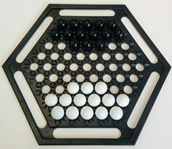
Abalone - How to Play
Estimated play time:
15-30 mins

Abalone is a two-player game where the aim is to push 6 of your opponent's marbles off the board. In order to play you set up the game as shown in the picture above.

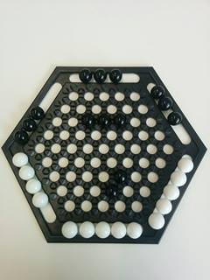
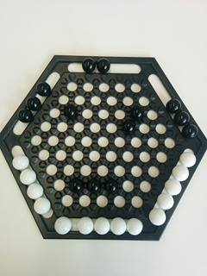

Black always starts first. A move consists of 1-3 marbles in-line moving one space in the same direction ('in-line', above left), either along the line or across onto another line ('broadside', above right).

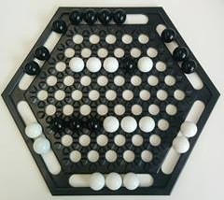
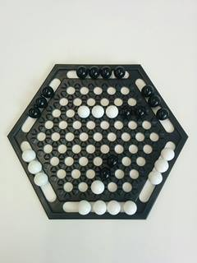

The above images show how you can move your opponent's marbles by performing a ‘Sumito’. You can only do this by performing an in-line move when your own marbles outnumber your opponents (up to a maximum of 3 marbles). You can't push your opponent's marbles unless there is a free space behind them or you are pushing them off the board.

Abalone - Strategy
Is there an advantage to going first?

Is there an advantage to controlling the middle of the board?
Is it better to cluster your marbles together or to have them spread out over the board?

What is the best move to make in the following scenario, where it is black to move?

