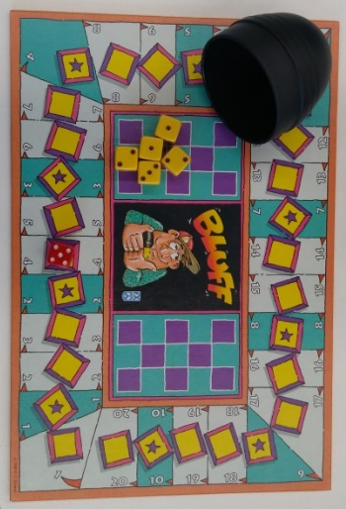
Bluff - How to Play
Estimated play time:
2 Player 5 to 10 minutes
3 + Players 10 to 30 + minutes
Bluff is a game similar to 'Dudo' and 'Liars Dice'. It is a popular game from South America based on the probability of dice rolls and the player’s ability to bluff about them.
Playing the game:
Each game must have a minimum of two players up to a maximum of six.
Each player starts the game with five dice and a dice cup.

Playing the game:
- All players roll their five dice under their cup.
- Each player can look at their own dice, BUT MUST KEEP THEM OUT OF SIGHT OF OTHER PLAYERS!!
- The first player must now bet on the number of a dice of a chosen roll which are in play. (NOTE: All the dice which have been rolled by all players are in play and dice with either the chosen value or star face up are counted as the chosen dice.)
- Any of the players now has the opportunity to identify if this player is 'Bluffing'.
- The next player must now, in turn, choose one of the options:
  - increase the number of the chosen dice they think are in play;
  - increase the value of the chosen dice (e.g. if the chosen dice roll is 3, players can increase the value to only 4 or 5).
- Steps 4 and 5 must now be repeated by each player until one player calls another's 'Bluff'.
- Once a player has called another players 'Bluff' all players must reveal their dice. If the player who identified the 'Bluff' was correct, the player who was incorrect must lose one of their dice. If the accuser was incorrect, then the accuser must lose one of their dice.
- Steps 1 to 7 must now be repeated until all players but one have no dice remaining.
Winning the game:
A player has won the game when they are the only player with any dice remaining.
Using the board:
(These rules can be ignored if players choose to play without using the game board.)
Players can choose whether or not to play the game using the game board. If players choose to use the board, the red dice is used for recording the value of the players chosen dice roll and the location on the board is used to identify the number of this dice in play. When a player moves onto a dice with a star on the game board, players are now betting on the number of dice in play with a star face up (not any other dice!).

Bluff Strategy
What roll gives you the best chance of winning?
Is it best to be the first player to place a bet?
Does this change depending on how many dice are in play?
Other than a good poker face, are there any other strategies that could improve your chances of winning?

What is better to roll, a high quantity of the same low number or range of different high numbers?
How much of an impact does the star (which can take any value on the dice) have on the normal probability of a six-sided dice?

Alternate rules
An alternative way of playing is where only the person betting after you can call you a liar.
Try letting the loser of the previous round make the first bet, does this make the game last longer?
For a simplified version of this game, you could try betting on the sum of the dice. This eliminates rolling pairs, or multiple dice from the betting. A star could be used as a six.
Use the board for this by multiplying the number on the board by the number on the dice. Examples are shown below:
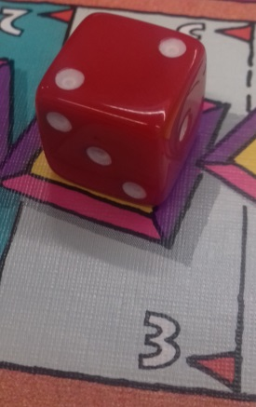 | 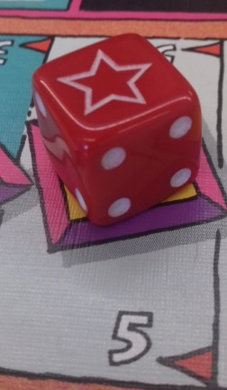 | 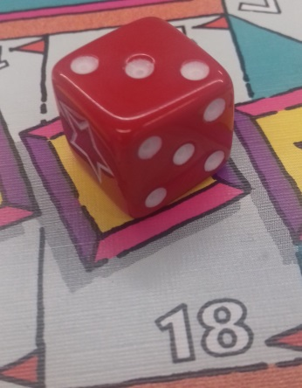
This is a bet of at least 6 | This is a bet of at least 30 | This is a bet of at least 54

