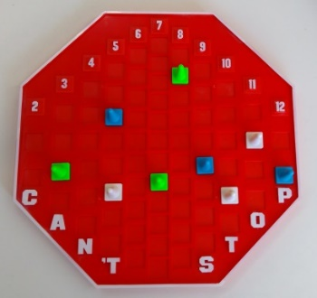
Can't Stop - How to Play
Estimated play time:
20-30 mins for 2 players
30-40 mins for 3-4 players

Can't Stop is a two-four player game where the aim is to get three of your cones to the top of the board and claim the columns before your opponent, by rolling four dice.

Pieces
Runners | These are the white cones you swap out for your coloured cones when it is your turn to move. These 'placeholders' are the only pieces that you can move during your turn.
Coloured Cones | Each player has their own set. These are used to track players progress in between turns.
Dice | These are rolled to determine the relative column you can move the Runners in. Adding together two dice determines which column you can place a runner in.
Board
The column number is listed at the top, these are the eleven possible numbers you can make by adding the dice. When playing, the 'Runner' cone starts at the bottom of the column and works to move to the top of the board.

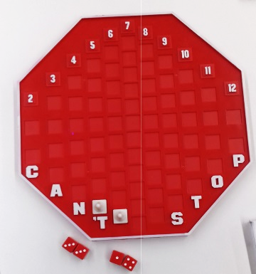
Taking Your Turn
- At the start of your turn, roll the four dice. The possible pairs of dice determine the columns each runner can start in. Each die can only be used in one sum.
- Players can then choose to roll again and add the third runner to the board. If possible, you must have all three runners in play.
- You can also use your roll to move existing runners towards the top. You may move one space for each pair of dice which sum to the column number they are on (e.g. if you roll an eight you may move a runner in column eight one space).

- After your first two rolls, you can choose to continue rolling the dice as many times as you like. If you can combine the dice to make the number of a column in which you have a runner, you can keep going.
- However, if the dice you roll cannot make a number which allows you to move, you lose any progress for your whole turn and must remove runners from the board.
- Alternatively, you can choose to finish your turn before this happens. To do this, replace the runners with your coloured cones.
- On your next turn, when you roll the columns where you have cones, continue by placing a runner one space along from your coloured cone.

Finishing the game
Once a runner reaches the top of the board, the column has been won. Doing this, you remove and return all your opponent's cones below your piece on this column. Won columns are out of play, no runners can be introduced to them at the bottom. Winning three columns means that you have won the game.

Can't Stop - Strategy
Is there an advantage to going first?
Are there certain columns which would be better to have your cones in?
Does this change at different points in the game?

Which of the numbers from two to twelve has the highest probability of being rolled? Does the column number accurately represent this probability? Are there any columns where you have a greater probability of winning with and are therefore a better choice to occupy?

What would be the result of allowing different mathematical operations with the dice (e.g. allowing players to subtract numbers or multiply numbers)? Does allowing this make the game easier or harder?

How would allowing different combinations of the four dice affect gameplay (e.g. allowing players to sum three dice and use the remaining one as oppose the two stated in the rules)?

Interesting dice rolls
Considering the dice rolls below, what are the available gameplay options at different points in the game (i.e. to the first player on their first go)?
Considering the rules and alternative rules stated above, is there a best option in each case?

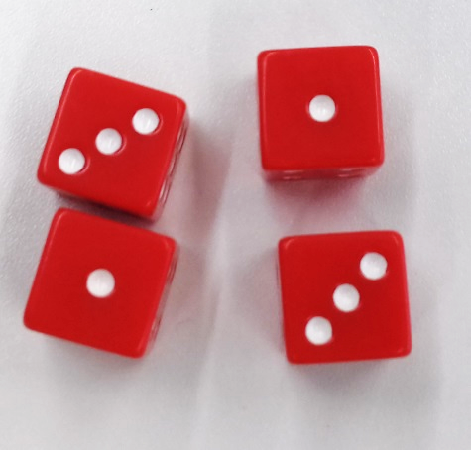


Want to look further into mathematical topics related to Can't Stop?
Consider probability of rolling dice and event outcomes.

