Connect 4 – How to Play
Estimated play time: 5 – 10 minutes
Players: 2

  - The aim of Connect 4 is to get four of your coloured counters in a row whilst preventing your opponent from doing so.
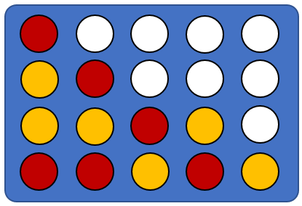
  - Playing the Game:
  - Each player starts by taking the 21 checkers of their chosen colour.
  - Players must take it in turns to slot a counter into the grid. Players can place a counter into any of the slots on the top of the grid.
  - This continues until a player gets four counters in a row either horizontally, vertically or diagonally. A player who has got four counters in a row has won.

  - NOTE: There is a slider on the bottom of the grid to easily remove the checkers.
Connect 4 – Strategy

  - Do players gain an advantage by placing the first checker?

  - Are there certain positions in the grid where players have more options when placing their counters and are there certain times when this is achieved?

  - Is there a position on the game board players should aim to control to increase their chances of winning?

  - On a player’s first turn, is there a best position to place their first counter?

  - Are there positions within the grid which can be considered the worst position to place a counter?

  - Are there strategies which can guarantee a win for either player?

  - How is the game like Noughts and Crosses? How is it unlike Noughts and Crosses?

  - Want to look further into Connect 4?
Look at James Dow Allen’s or Victor Allis’s research into the game Connect 4.

