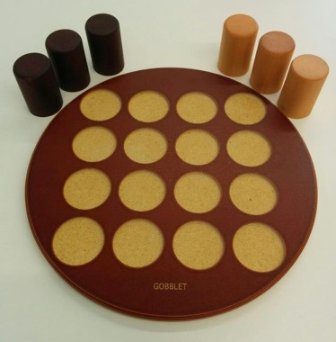
Gobblet - How to Play
Estimated play time:
10-15 mins

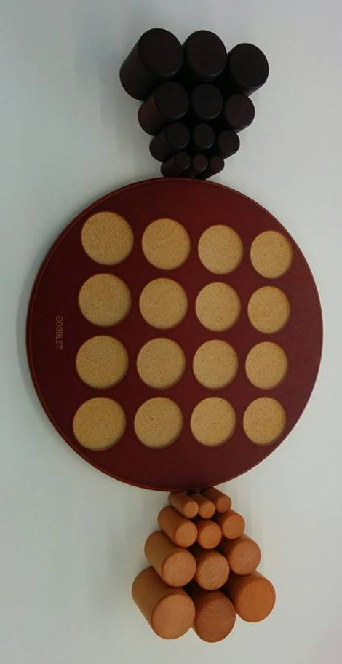
Gobblet is a two-player game where the aim is to get 4 of your Gobblets in a line on the board (horizontally, vertically or diagonally). In order to play you set up the game as shown above (where the smaller Gobblets are hidden under the larger ones).

Each player takes it in turns to place down a Gobblet; they have to be placed in order, always taking a Gobblet from the top of any of their three stacks. Throughout the game visible Gobblets can picked up from the board at any time, however once picked up they have to be moved to another square on the board.

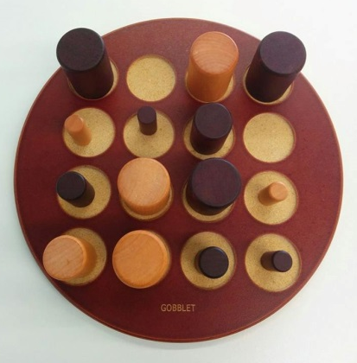

Players can 'Gobble' any smaller pieces of either your opponent’s or your own Gobblets at any time using Gobblets currently in play. Gobblets that have yet to be placed on the board must be played onto empty spaces. There is one exception: if there is a visible line of three of your opponents Gobblets, you can 'Gobble' one of them, by placing a Gobblet over smaller pieces of either your own or your opponents Gobblets.

Gobblet - Strategy
Is there an advantage to going first?

Is there an advantage to controlling the middle of the board?
Is there an advantage to holding back larger pieces at the beginning?

In the scenario below how can black win on this turn?
