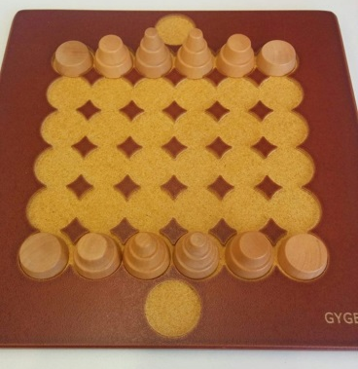
Gyges - How to Play
Estimated play time:
15 - 25 mins

Gyges is a two-player game where the aim is to get a piece to the end space on the opposite side of the board. Pieces don't belong to either player. To move to the end space, a piece must be in one of the spaces in the line immediately before it and have one move remaining. In order to play you set up the game as shown in the above picture.

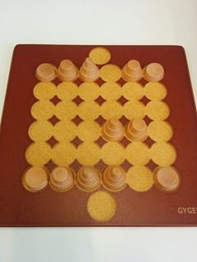

Players then take turns to move pieces from their backline (i.e. the line of pieces nearest their starting line). Each of the pieces move an initial distance corresponding to how many tiers the piece has (e.g. 2 tiered piece moves 2 spaces). Pieces can move in any direction except diagonally.

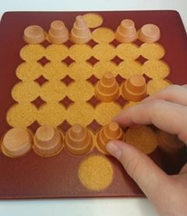
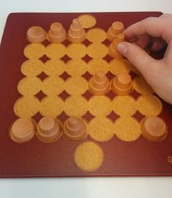
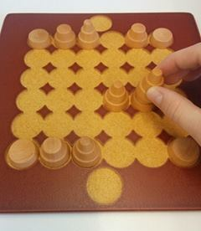

At the end of a move only, a piece can land on an occupied space. When landing on an occupied space the piece moves again by the number of spaces equal to the tiers of the piece it landed on as shown above.

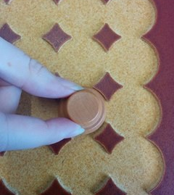
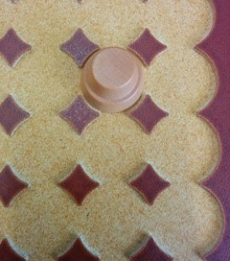
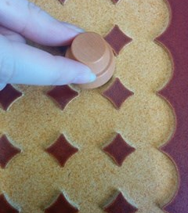

The above shows that a piece may move in any direction but may not leave a space the same way that it entered on that move.

Gyges - Strategy
Is there an advantage to going first?

Is there an advantage to keep a triple piece on your backline until last?
What is the fastest way to get a piece to the opposite side of the board?

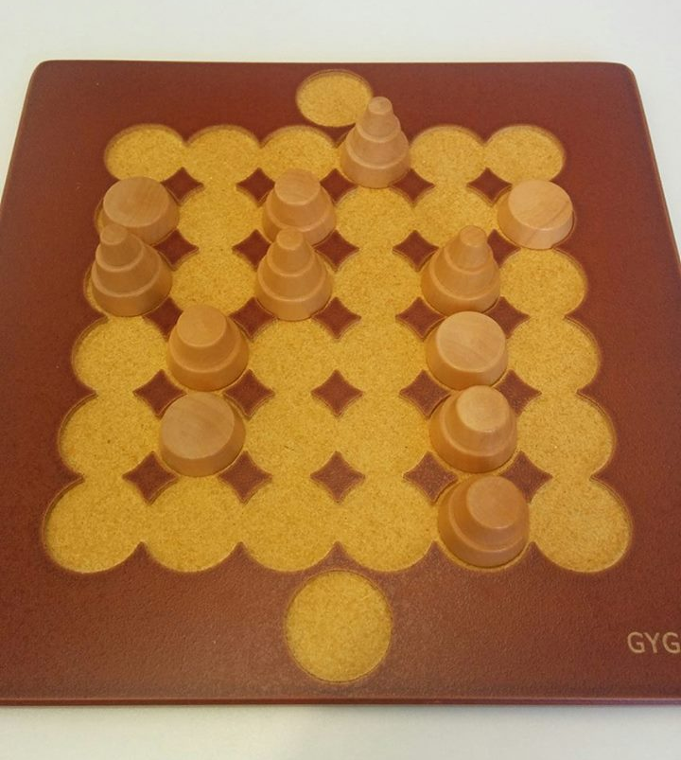
By moving the piece shown by the BLUE arrow below, what is the best move to make in the following scenario?

Advanced game
In the more advanced version of the game, when a piece lands on an occupied space you can do any one of the following:
- Jump as you would in the simple rules
- Replace the piece occupying the space with the one in your hand, the piece picked up can then be placed anywhere on the board, provided it is not placed behind your opponents backline.
Repositioning can take place at the end of a series of jumps.

