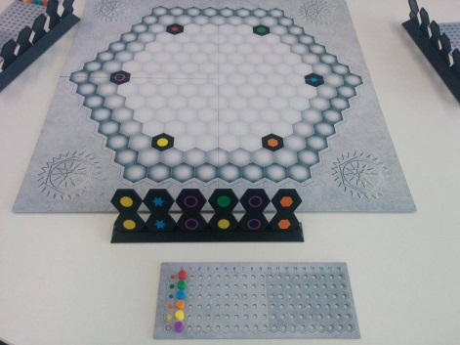
Ingenious - How to Play
Estimated play time:
30-45 mins

Ingenious is a two-four player game. Players collect points on six colours. A player's score is the number of points on their lowest scoring colour. In order to play you set up the game as shown in the picture above, each player draws 6 tiles from the bag. When playing with two players, you use the white spaces, three players use the light grey spaces and the four players use all of the board.

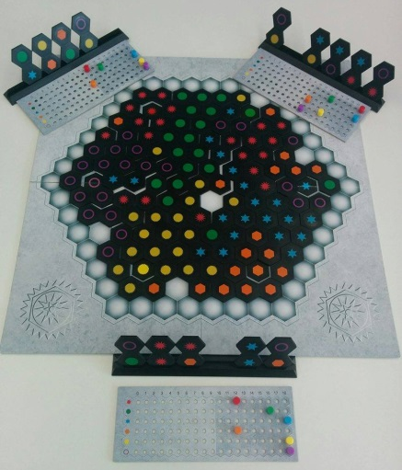

The order of play is clockwise. To play, place one of your tiles so that at least one colour is adjacent to the same colour already on the board. In the first round each player must play adjacent to a different one of the six starting colours already on the board. At the end of your go, select tiles from the bag to refresh your rack to six.

To score you identify lines of the same colour that your tile has formed with the tiles already on the board (see pictures below). You count the number of each colour in each line formed excluding the tile you just placed. Your score in each colour is the total number in that colour you have counted. Follow the example below.

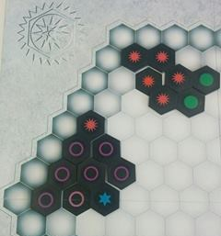
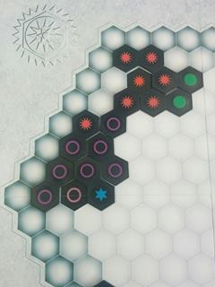

Purple - 5
Red - 3
Purple - 3

Immediately after you have played and before you have refreshed your tiles, if your rack of tiles doesn't contain any of your lowest scoring colours then you may refresh your entire rack. Show your tiles to the other players before drawing six new tiles, and place the old tiles back in the bag.

When you get a score of 18 for one of your colours, call out "Ingenious" and get a bonus play. Select another tile from your rack, score it and then replenish your rack.

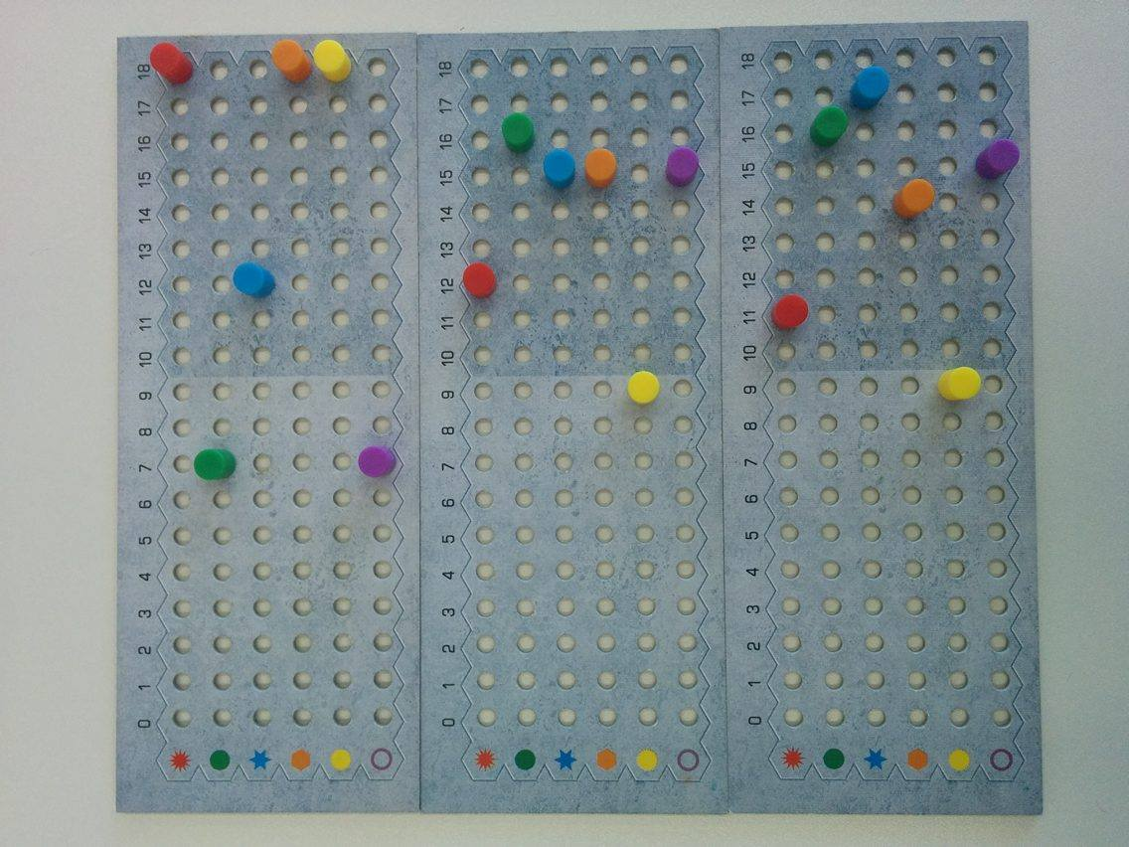
At the end of the game the players lowest peg is their final score and the highest score wins. In a tie-break situation, you look to the second lowest peg, to see who has the highest score. If this does not determine a players finishing position, continue to look at the third pegs and so on.
The scorecards on the left show that player 2 has won as it has the highest score, as player 3 has also got a score of 9 but they lose out in the tie-break of the second peg, 11 - 12. Player 1 comes last with a score of 7.
Player 1
Player 2
Player 3

Ingenious - Strategy
Is there an advantage to going first?

Is there an advantage to building up particular colours or to evenly bring up all the colours at the same time?

How does the strategy change with a different number of players?
When playing double colour tiles is it better to play them straight away or to keep them for later?

