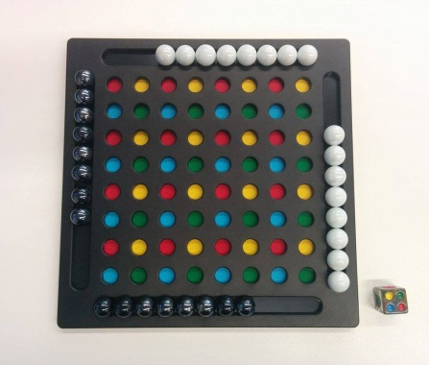
Joggle - How to Play
Estimated play time:
5-10 mins

Joggle is a two-player or two-team game where the aim is to get 6 of your marbles in a rectangle shape on the board. In order to play you set up the game as shown in the picture above.

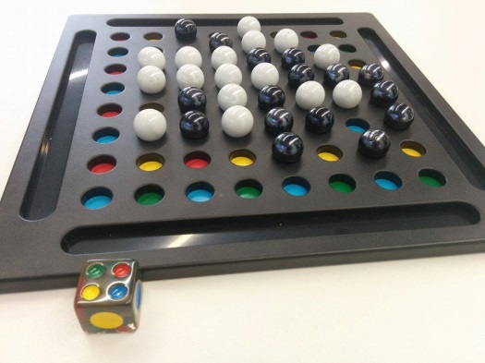

Basic Game - Joggle Six
Each player takes it in turns to roll the die; they then place one of their marbles down corresponding to the colour rolled on the die. The "Joggle" side contains all of the colours and the player can move onto any colour.

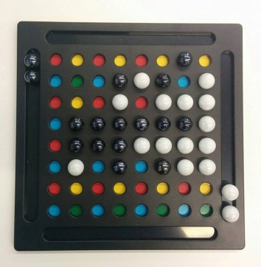

When all marbles have been placed on the board players then select any of their marbles and move it according to the die. Alternatively, if a "Joggle" is thrown they can switch a marble with one of the opponents. This move cannot be made if it completes a rectangle.

Joggle - Strategy
Is there an advantage to going first?

Is there an advantage to controlling the middle of the board?
Is it advisable to space out your marbles or to start making a Joggle straight away?

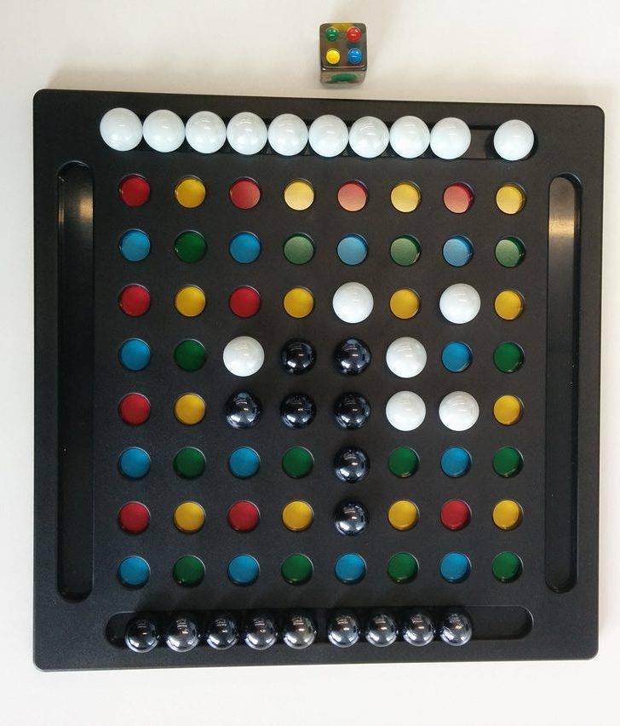
In the scenario below, white has rolled a Joggle, what is the best move to make?

Advanced Game - Joggle Four
In this version of the game the objective is to place your marbles into four squares of four marbles each. The rules of the game are the same as in Joggle Six so a square cannot be completed by swapping positions with an opponent’s marble and a completed square cannot be broken by a "Joggle".

