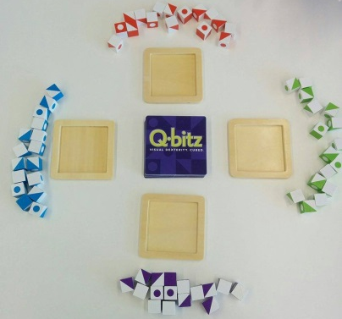
Q-bitz - How to Play
Estimated play time:
10-15 mins

Q-bitz is a two-four player game where the aim is to recreate the patterns on the game cards, using the set of cubes. In order to play you set up the game as shown in the picture.

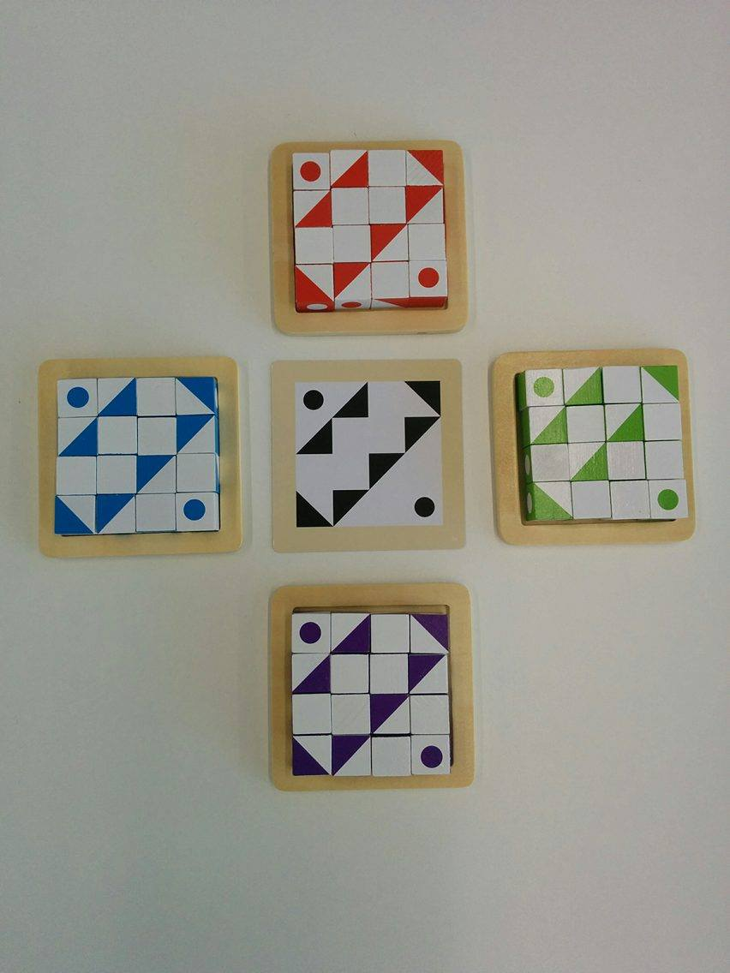

Each player receives their own set of 16 cubes and wooden tray. A card is selected at random and placed so that everyone can see it. There are three rounds of games. The player who collects the most cards wins the game.

Round 1: Race to recreate the pattern shown on the card using your set of cubes, rotating the cubes in anyway. First player to complete the pattern correctly wins the card.

Round 2: Roll all of the cubes on the table like dice and use as many cubes as possible without changing the orientation to recreate the new pattern. Race to re-roll the remaining cubes to obtain the correct orientation. First player to complete the pattern correctly wins the card.

Round 3: Players have 10 seconds to study the card. Then turn the card the face-down and race to recreate the pattern. The player who is first to recreate the correct pattern or the player with the most cubes in the correct place wins the card.

Q-bitz - Strategy
Is it better to look for pieces with the correct orientation or pick up a piece and give it the correct orientation?

Is it better to work from the outside inwards or to work row by row?

How does the memory round increase the difficulty?
Does the practice of round 3 increase your ability in rounds 1 and 2?

