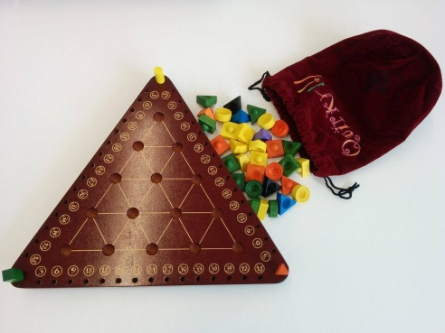
Quirky - How to Play
Estimated play time:
15-20 mins

Quirky is a two-three player game where the aim is to score the most points by creating equilateral triangles that share the same top colour piece. Keep score by using your designated score keeper along the score track on the edge of the board. With two players, the third colour Quirk is used as a placeholder.

Each player takes it in turns to pick a piece, called a Quirk, from the Quirky bag. The Quirk can be placed on the board (unless it is a special Quirk - see below) but can only be placed on another Quirk to block or form a triangle. You cannot place the same colour on top of each other and you can only stack Quirks three high.

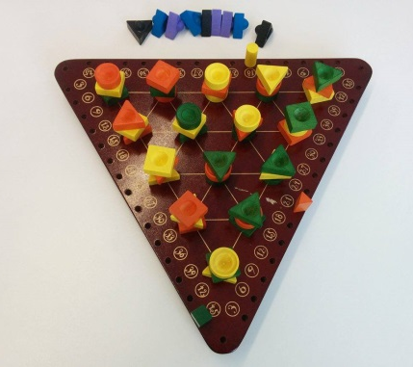
Special Quirks
Purple - Pass the coloured score keepers to the player on the left. Your score remains unchanged, but you are now a new colour.
Blue - Move any "top" Quirk to an adjacent position. The placed Quirk and the exposed Quirk can score points.
Black - Remove any "top" Quirk and return it to the bag.

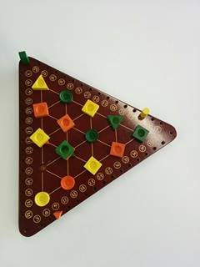
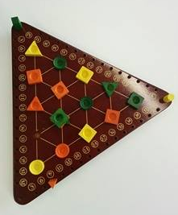

Points are scored when equilateral triangles of any size are formed, you may win points for your opponents. Each triangle with three vertices the same colour scores three points. Above, yellow scores nine points for forming three triangles.

The game ends when all of the Quirks have been placed down and the player with the highest score wins.

Quirky - Strategy
Is there an advantage to going first?

Is there an advantage to controlling the corners of the board?
How important is considering the purple Quirk when making a move?

In the scenario below, you are yellow. Where can the green Quirk be placed to make sure your opponent receives the least number of points?
