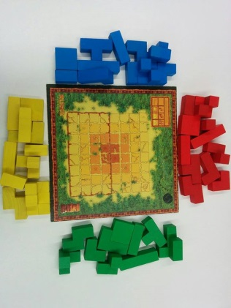
Rumis - How to Play
Estimated play time: 15 - 30 mins

Rumis is a 2 to 4-player game where the aim is to have the most amount of your colour when looking from above the top of the board.
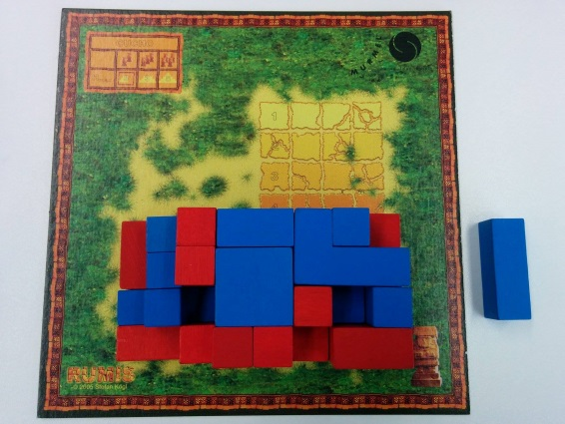

On the first go a player places a piece within the building limits; other players’ first piece must have a face touching an opponent’s piece. After this first round, each player must play their piece with at least one face touching a piece of their own colour. Each player takes it in turns to place a piece down on board, all pieces must stay within the building plan limit and there can be no overhanging pieces.

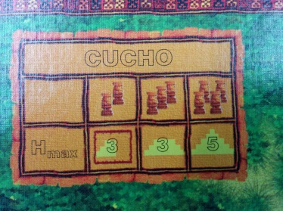
Number of players
Building Boundaries

Players must stick within the heights allocated; if a player can't play a piece then they are not allowed to place down further pieces for the remainder of the game.

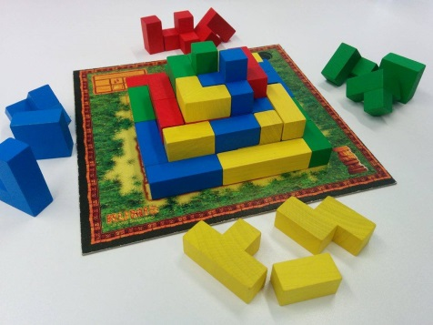

At the end of this game count up the number of top facing squares for your colour, reduce a point for each piece not placed.

Rumis - Strategy
Is there an advantage to going first?

Does the strategy change when playing with a differing number of players?

Is there an advantage to using the more awkward-shaped pieces first?

In the scenario below what's the best move for red to do?

