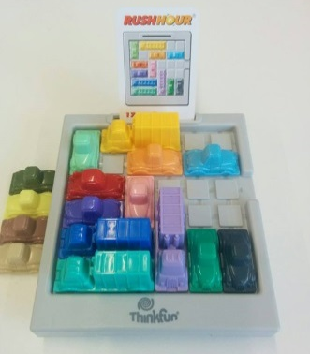
Rush Hour - How to Play
Estimated play time: 2 - 3 mins per challenge card

Rush hour is a single-player game where the aim is to slide the cars around the playing grid in order to slide the red car out of the exit. We have multiple sets of the game so it is possible to race your friends.

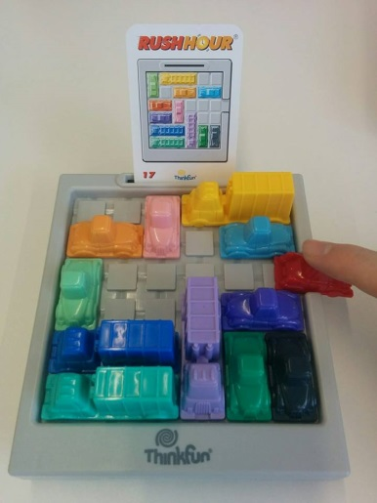

In order to play you set up the game according to the picture on the challenge card, then slide the cars around without removing them from the grid to slide the red car out of the exit.

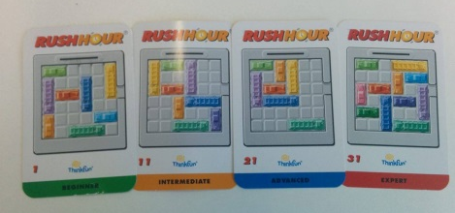

The challenge cards provide four different levels of difficulty ranging from beginner to expert. On the reverse of the challenge cards there is a solution to that traffic jam.

