Set – How to Play
Estimated play time: 5-10 minutes
Players: 2-20
Set is a card game based on patterns of differences and similarities in cards.
Players lay out 12 cards and race to make a 'set' before everyone else.

What is a set?
A set is 3 cards which all have some things in common, and all have some things that are different. The cards have 4 different variables:
- Colour - Red, Green and Purple
- Symbols - Ovals, Squiggles or Diamonds
- Number - One, Two or Three
- Shading - Solid, Hatched or Open
Each card is a combination of a colour, a symbol, a number and a type of shading. This leads to a lot of different possible card combinations. Two examples of sets are shown below; some examples that are not sets are shown overleaf.

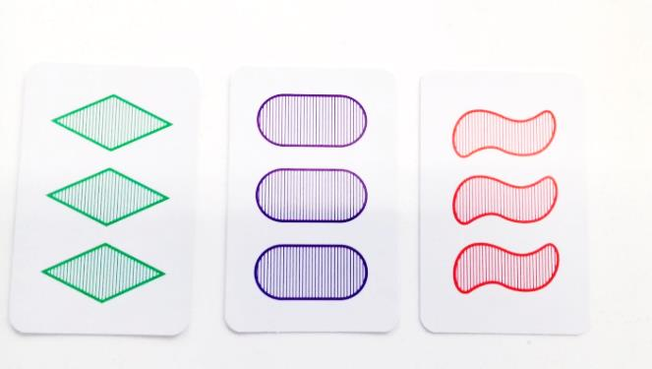
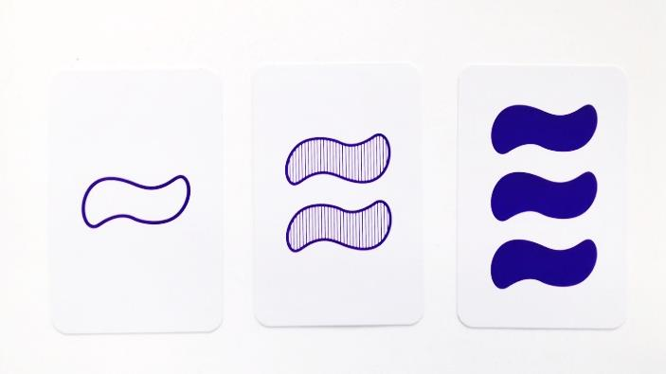
Same: Shading & Number
Different: Colour & Symbol
Same: Colour & Symbol
Different: Shading & Number

How to Play
- The game starts by the dealer shuffling together the two decks of cards. They then lay down 12 cards face up in a rectangle in the centre of the table.
- Everybody looks at the 12 cards to see if they can see a set, when you think you can see one you must say 'Set’ and pick up the three cards you have chosen.
- The game stops and everybody checks to see if you are correct.
- If it IS a set, you win one point and keep the set. The dealer replaces the three cards taken with ones from the shuffled deck.
- If it IS NOT a set you must deduct one point from your score, return the three cards, and the game continues.
- If everybody can agree that there is no possible set available, the dealer must add 3 more cards to the rectangle to make 15. When a set is found, the cards are not replaced to keep 12 cards within the rectangle.
- The game is finished when the deck has gone and no more sets can be found. The person with the most points wins.

Set - Strategy
Is it advantageous or disadvantageous to being the person dealing the cards?

Is it possible for there to not be a set within the cards dealt? If so, what would be the probability of this occurring? Does a certain number of cards guarantee a set every turn?

Are there any ‘easy’ sets to look for, or any which are more likely to occur?
It advantageous to look for just differences or similarities?

Alternative Strategies
How is gameplay affected if you get points for the number of true properties?
i.e. Players identifying a set with three cards the same colour, shape, and markings but a different number on the cards would score three points as oppose to two.

Does taking turns with dealing the cards or having a specific point from which players can look at the face up cards improve gameplay?

‘Tricky’ Sets
To ease decision making the below examples are all NOT SETS which may not be obvious at first glance.
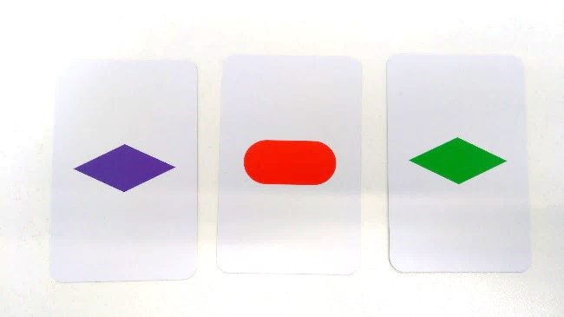 | 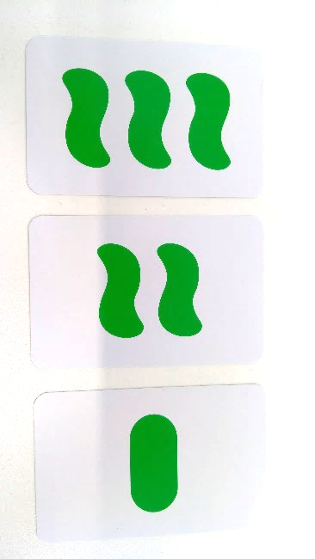
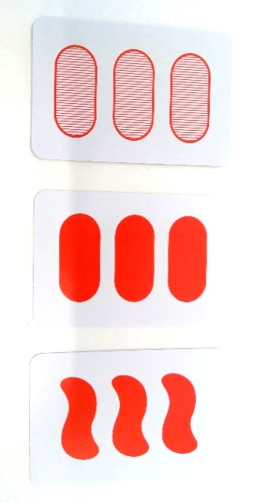 | 