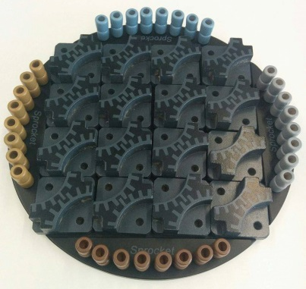
Sprocket - How to Play
Estimated play time:
15-20 mins

Sprocket is a two-player or four-player game where the aim is to be the first player with all of your pegs in play. In order to play you set up the game as shown in the picture. For two players, each must have 32 of the same coloured pegs and for a four-player game, each must have 16 pegs of their own colour.

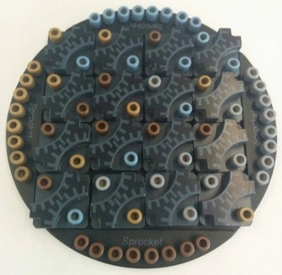

Each player takes turns to place a peg into the small openings on the board until all of the rotors are filled (you should have half of your pegs remaining).

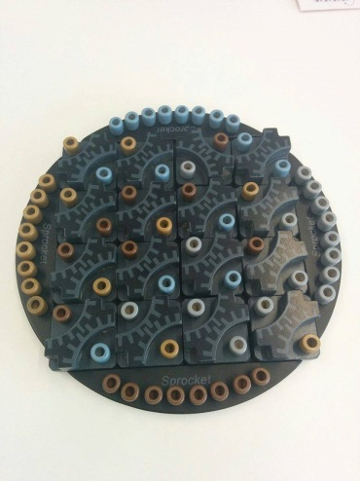
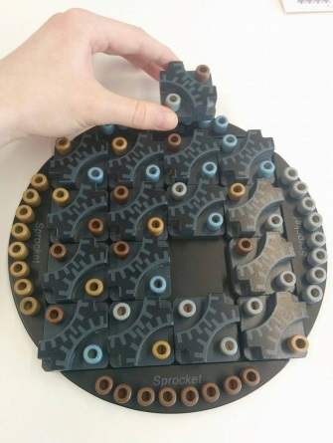
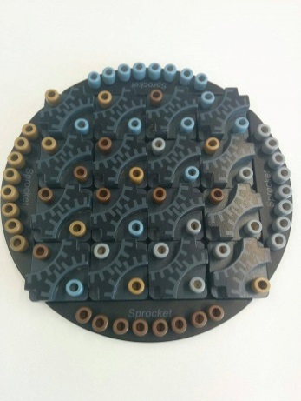

You then take turns to pick up a rotor that has one of your own pegs on them and slide it into a new position along the perimeter. The rotor can also be rotated in any way. You cannot place the rotor in the same place. This is displayed above.

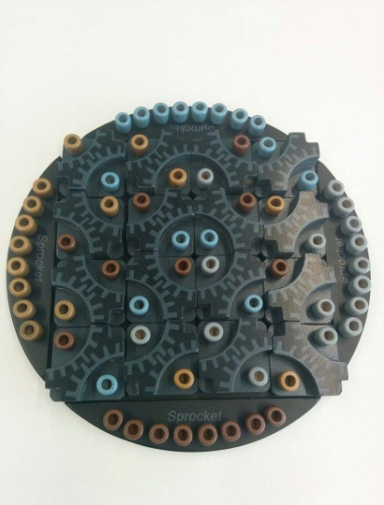
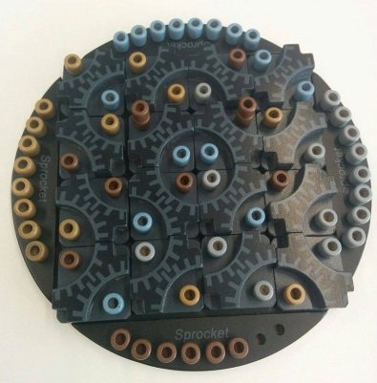
Before
After
On the left a gear has been created as indicated by the red square. In this case, the player using brown pegs made the gear and so they can place an additional brown peg on top of existing brown pegs on the surrounding rotor pieces not in a gear as shown by the diagram on the right.

If you create a gear containing different sized stacks, regardless of who created the gear all of the pegs inside the gear can be increased to the same height as the tallest stack inside the gear. Below is an example of a winning move being performed in a 2 player match (Player 1: Brown/Gold vs Player 2: Blue/Grey).

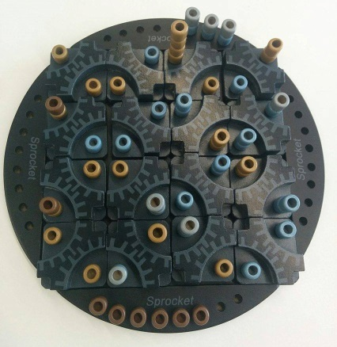
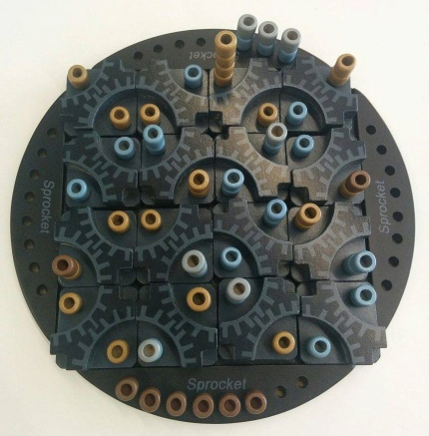
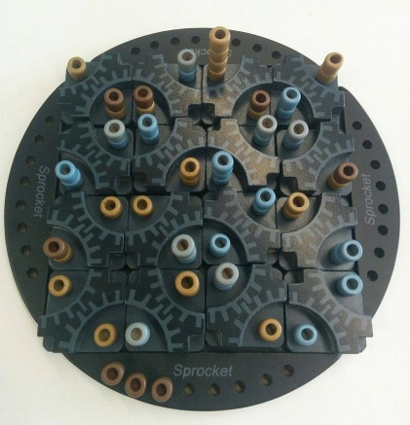

The first picture shows the move performed by Player 2; indicated by the green arrow in the second picture. The second picture shows the creation of two gears and the third picture shows where pegs have been added as a result of the move. As each gear has a tallest stack of 2, the stacks inside the gear are increased to 2 by all players. As explained earlier, Player 2 increases the height of all their surrounding stacks which are not in the gear by 1 (circled for clarity). Player 2 is victory as they have used up all of their pegs.

Sprocket - Strategy
Is there an advantage to going first?

Is it better to allow your opponents the chance to create gears to get better opportunities for yourself later on, or to contain their chances and hinder yourself?

Is there an advantage to controlling a whole rotor piece?
Does the strategy change when playing either a two or four player game?

