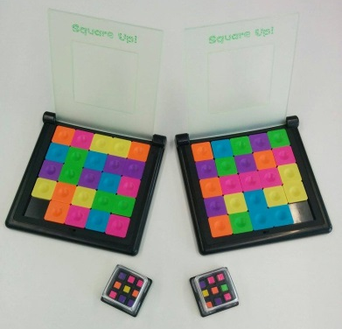
Square Up! - How to Play
Estimated play time:
2-5 mins

Q-bitz is a two-player game where the aim is to recreate the patterns on the cube shaker, using the set of sliders. In order to play you set up the game as shown in the picture.

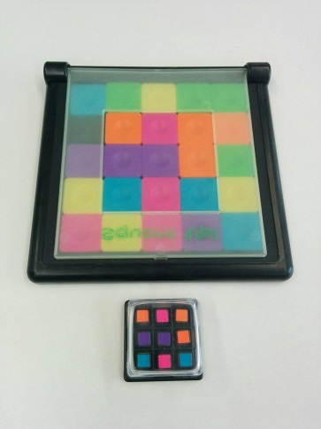
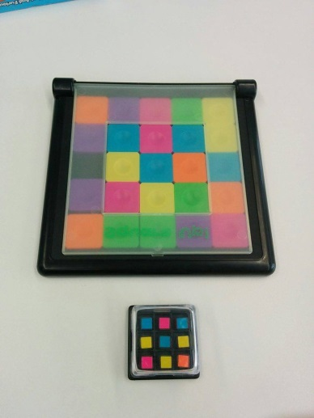

Each player receives their own cube shaker and set of sliders. Shake your own cube shaker to create a 3 by 3 colour pattern. Then race each other to create the pattern in the central squares of your slider, like the completed pattern shown above.

The player who completes their pattern correctly and slams down the lid first is the winner.

