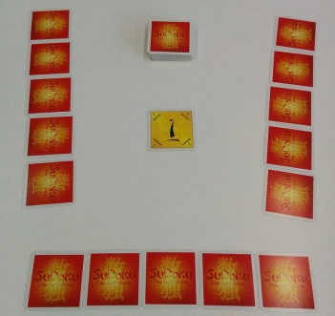
Sudoku card game - How to Play
Estimated play time:
20-30 mins

Sudoku is a two-five player game where the aim is to get the least number of points in your penalty stack. In order to play you set up the game as shown in the picture above. Place any one of the yellow cards face-up in the middle then shuffle the remaining yellow cards with the blue cards and deal out five cards to each player.

Each player takes it in turns to place down one of their cards face up, adjacent to at least one of the cards that have been placed down. Blue cards can only be placed in one of the eight positions around a yellow card; this creates 3x3 "boxes".

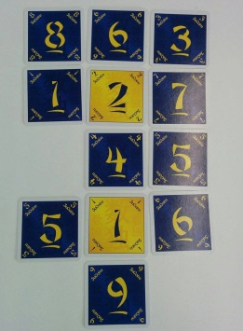
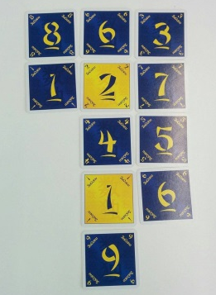

Yellow cards can only be placed vertically or horizontally to another yellow card and must have a blue card between them. All the numbers in any row, column or "3x3 boxes" must be different, even across gaps. As shown above five cannot be placed anywhere as there is already a five in the box.

If a player places down a card incorrectly and is noticed before the next card is played then the player must retrieve the card and place it onto a penalty stack in front of him. If an incorrect play is discovered later, the layout unchanged and leave the incorrect card where it is. If a player is unable to play a card or chooses not to, he must select a card and place it in his penalty stack. When a player has placed down a card they must pick another card from the deck.

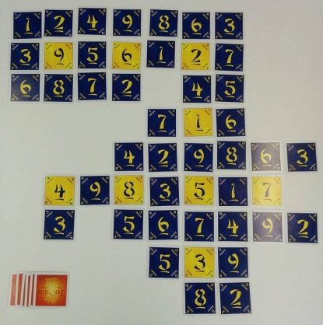
The game ends when the deck has been used up and all cards have been played. Each player totals the number of cards in his penalty stack with each blue card counting as 1 and each yellow counting as 2. The player with the lowest score wins.

Player 2 penalty stack
Player 1 penalty stack
Sudoku card game - Strategy
Is there an advantage to going first?

Is there an advantage to keeping the yellow cards for a long as possible?
Is it better to place yellow cards in the same area, to make it more difficult or to expand outwards?

In the scenario below what is the best move to make?

