Toscana – How to play
Estimated Play Time: 20 minutes
Players: 2

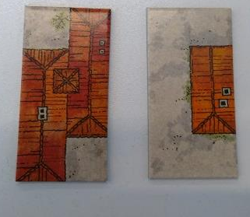
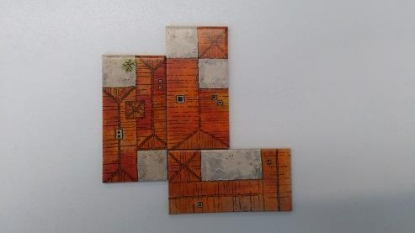
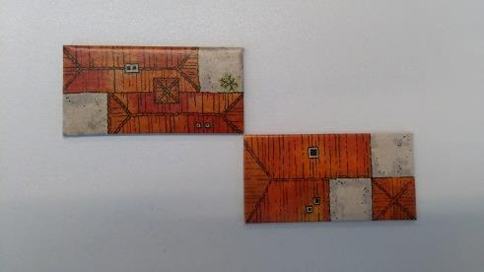
Finishing the Game:
- The game is finished when there are no tiles remaining in either player's possession or no player can place another tile down.
- The winning player is the player with the largest single block of tiles. (Only one block can be counted and the block must only count tiles join by an edge/side, not by a corner.)
Starting the Game:
- Each player must pick one of the two types of tiles, the 'Roof' or the 'Courtyard'.
- Each player's tiles have 6 squares of their own type, and two of their opponents. Players must collect the 16 tiles of their type and place them face up on the table.

Toscana is a two-player game where the aim is to join as many of your tiles together to make the biggest possible block of your colour. The winner is the player who has the single largest block of their colour.

Courtyard Tile
Roof Tile

Correctly Joined
Incorrectly Joined
Playing the Game:
- Each player takes it in turns to place a tile upon the game board.
- Each newly placed tile must join onto one of the previously placed tiles already on the game board.
- The objective of the game is to join as many of the tiles together to create the largest possible single block of your own colour tile.

Toscana - Strategy
Is there an advantage to going first?
How easy is it to follow your opponent's movements?

Are there any pieces which are best saved for certain situations?

Is it possible to play the game without leaving any gaps of the grass?

When playing, is it best to avoid or stay near to the edges of the board?
How important is blocking to seal your opponent in, at different points in the game (see below)?

How important is 'branching out' in different directions, as the game progresses
(see below)?

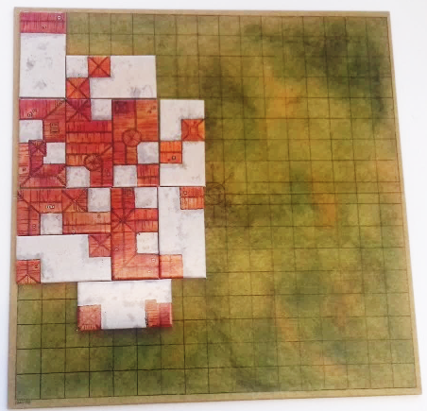 | 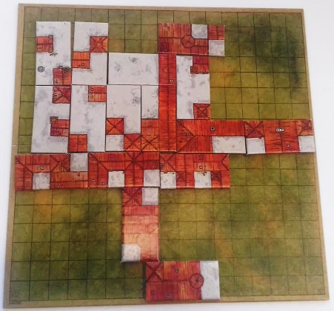
Courtyard is 'Blocking' | Roofs are 'Branching out'
Alternate Rules:
Here are some alternate ways you can play for interesting results.
Different starting points:
Instead of starting in the middle, start in a corner opposite to your opponent. Does this make your opponent easier to predict? What is the best direction to branch out into?
Different Tiles:
It may be interesting to start with a combination of both tiles, so that you must prioritise your tiles more.
You could start the game with:
- randomly shuffled tiles, shared between you and your opponent;
- half your opponents tiles and half of your own.

