Tri-Ominos – How to Play
Estimated Play Time:
15 minutes 2 Players, 30 minutes 3-6 players

Scoring:
Each player scores the sum of the numbers on the Tri-Omino they last placed (e.g. if a player places the Tri-Omino with the values, 2, 3 and 5 they score 10 points).
In addition, players also score additional points for making one of the following shapes when placing their Tri-Omino.
Bridge | Hexagon | Double-Hexagon
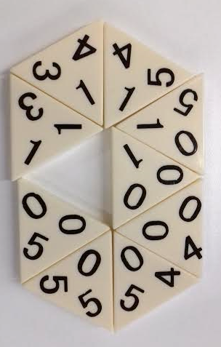 | 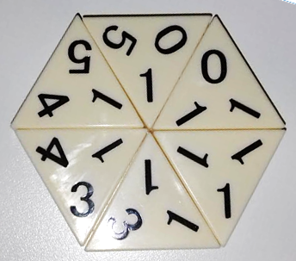 | 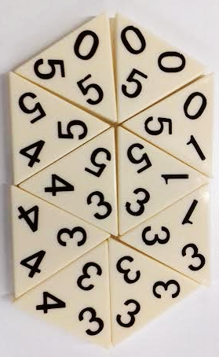
+40 pts | +50 pts | +60 pts
If a player is unable to place one of their Tri-Ominos on their turn they MUST 'buy' a Tri-Omino. Buying a Tri-Omino comes at a cost of -5 points. This can happen three times if a player cannot place a tile. After this, players MUST forfeit their turn at the cost of -10 points.

Playing the Game:
The starting player places down the first Tri-Omino of their choice. The next player must then place a Tri-Omino with a pair of matching numbers joining onto the first player’s Tri-Omino. This continues until one player runs out of Tri-Ominos to place down or until no player can place any of their remaining Tri-Ominos.
Preparing the Game:
Before play can begin the tiles must be placed face down on the table and each player must choose their tiles from the tiles available. The numbers of tiles to select are:
2-Players | 3-4 Players | 5-6 Players
9 Tri-Ominos Each | 7 Tri-Ominos Each | 6 Tri-Ominos Each
Each player must now randomly select one of the remaining Tri-Ominos and the player with the smallest sum of the numbers on their selected Tri-Omino starts the game.
Tri-Ominos is a game which is like dominoes. The objective is to use all your tiles by pairing them with matching tiles which have already been placed down.
Winning the Game:
If the game has ended from a player placing their last Tri-Omino, the game ends and no extra points are lost. If the game ends for any other reason, points are lost for each Tri-Omino any players may still have in their possession.
Once gameplay has finished the winning player is the player with the most points after any deductions.

Tri-Ominos - Strategy
Is there an advantage to placing the first Tri-omino?

What is the biggest score you can get from placing one Tri-omino?
Which tiles are the easiest or most rewarding to play?
Does this change depending on the game, or are there Tri-ominos which are always good to have?

In practice, how often do you get the opportunity to complete a shape?
Is it easy to stop someone from doing this?

Without knowing what tiles you opponent has, how easy is it to predict your opponent’s moves based on the Tri-ominos in play?

What is the best way to win, scoring points by making shapes or trying to place all of your
Tri-ominos as soon as you can?

Alternate Play Styles
Length of game:
You can change the length of the game in multiple ways. An effective way to do this is change the number of tiles everybody starts with (e.g. starting with 5 for a short game, or 11 for a long game). You can also set a goal score, so that when a player reaches this number they have won.
Different Calculations:
When calculating your score, you could multiply the numbers instead of adding them (e.g. instead of $3+5+2=10$ you get $3 × 5 × 2=30)$. When playing this way, you may want to reduce the score you get from making shapes; this will ensure the scores don't get too big.
Different Shapes:
As well as awarding points for the original shapes, you could add some more of your own (e.g. triangle).
You could also use symmetry and rotational symmetry as a way to score (examples shown below).
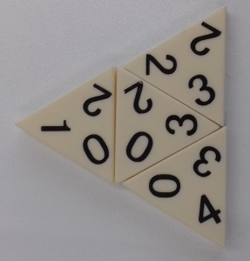 | 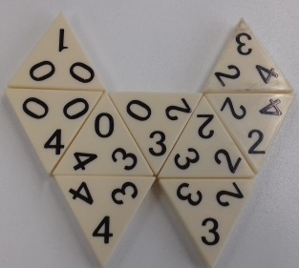 | 