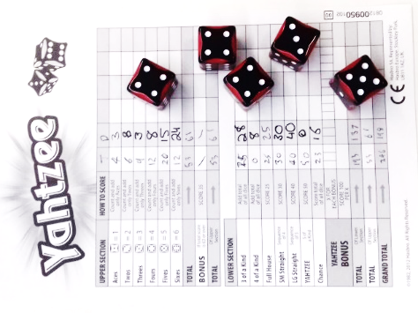
Yahtzee - How to Play
Estimated play time: 15-30 mins
Players: 1+

Yahtzee is a dice rolling game, based on taking chances and probability. Rack up the highest score by going for roll combinations (a bit like Texas Hold'em poker).

Score Card:
- Start by writing the initials of the players in the top row of the table.
- The table has the available combinations down the left-hand side; this is how you are scored.
- Your aim is to complete one of these thirteen combinations and fill in the corresponding score box each turn. More about the scoring below.

Your turn:
- During your turn, you may roll up to three times.
- Roll all 5 dice. Now you may want to decide which 'Combo' you are going to try and get, depending on what you rolled. Choose any number of dice to re-roll; you may want to roll just one or two, or all the dice.
- After this, re-roll any number of dice again. This is your third and final roll. Now you must record a score in an appropriate box of the score card. If you cannot fill in any 'Combo' box with the dice you have you must put a zero in one of your empty boxes.
- Once a box has a number in it, it cannot be changed. The game ends after 13 turns, when everyone has all the boxes in their column filled.
- You can choose to stop rolling at any point during your turn, for instance, if 'Yahtzee' is rolled immediately.
Scoring:
The scores on your sheet are divided into set and total scores. These are calculated differently in the upper and lower parts of the score sheet. The table below explains how this is done.

SET
TOTAL
This type of score is a set amount that doesn't change.
Upper
Lower

Add up only the appropriate dice for your score (if rolling 2’s only count 2’s).
Add up all your five dice for your score.
Bonus Scoring:
Yahtzee is the only score you can log on your score sheet multiple times. If you score more than one Yahtzee put an 'x' in a 'Yahtzee Bonus' box at the bottom of the score sheet, worth 100 points. This counts as one of your thirteen goes, so you must add your dice and log your score in the appropriate upper section box. If this box is full you must log it in one of the lower section boxes, be sure to write down the set score. If you have a zero in your Yahtzee box you cannot do this.
You can also get 35 bonus points for scoring 63 or over in the Upper section of the sheet.

Yahtzee - Strategy
Is there an advantage to having the first roll? What about the last roll?
What is the maximum possible score you could get on a single turn?
Is there a certain dice combination which gives this score?
What is the probability of a straight occurring when rolling all 5 dice?
Is it better to fill in any of the boxes first?
Are there certain boxes which should be saved as a back-up for poor rolls?
Want to look further into Yahtzee, look at the probability of dice rolls.
Considering the game below, if on Alice's third throw she rolls 6, 5, 3, 6, 4, what is the highest possible score she can achieve?
Upper Section: |  | A | B |  | Lower Section: | A | B
Aces | 1 | 3 | 0 |  | 3 of a Kind
Twos | 2 | 4 | 8 |  | 4 of a Kind
Threes | 3 | 3 | 0 |  | Full house |  | 25
Fours | 4 |  |  |  | Small Straight | 30
Fives | 5 | 5 |  |  | Large Straight |  | 40
Sixes | 6 |  |  |  | YAHTZEE | 50 | 50
 |  |  |  |  | Chance | 15 | 21

Other things to consider:
- If Alice, on her first roll, gets the dice combination 1, 2, 3, 4, 5 and 5. By re-rolling one of the 5's what is the probability of achieving a straight on the remaining two rolls?
- Suppose Bob has rolled 5, 4, 4, 3 and 3 on his second roll and decides he wants to fill in his 'Three of a Kind' box. Considering the probabilities of the different dice,
  - Would it be a better option to re-roll just the 5, or three of the dice leaving only an identical pair remaining?
  - If Alice was in this position instead, would her best option for maximum points be the same as Bob?

