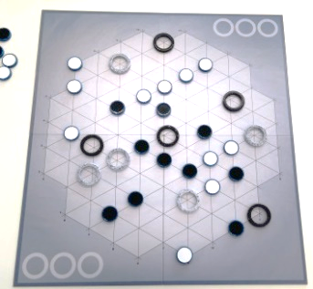
Yinsh – How to Play

Estimated play time: 10-15 minutes
Players: 2

Yinsh is a game where you flip 'markers' by moving rings around a grid.
The aim of the game is to make three rows of five markers before you opponent does.

Starting the game:
The game starts with players alternately placing each of their five rings at intersections on the grid.

How to play:
Players take turns to move their rings around the grid. This is done by:
- First place a marker inside the ring you want to move with your colour facing upwards.
- Move the ring as far as you like in any direction, however, you can only move over one 'set' of markers. This can be one marker or a long row of markers, as long as the row does not have any gaps. Once you reach the end of this set you must place your ring after the last marker (see picture below).
- You cannot move your ring over other rings.
- Any marker that you move over with your ring is flipped to reveal the colour on the other side of the marker (regardless of whose marker it is).
- Once this has been done your turn is over, it is now your opponents turn.

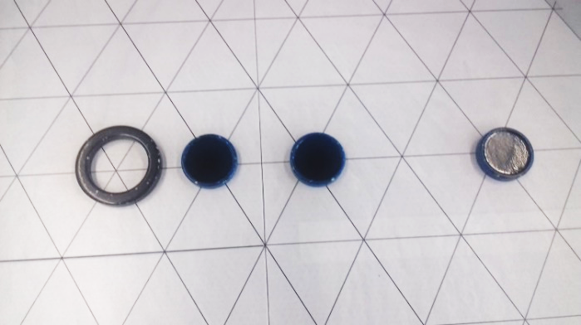
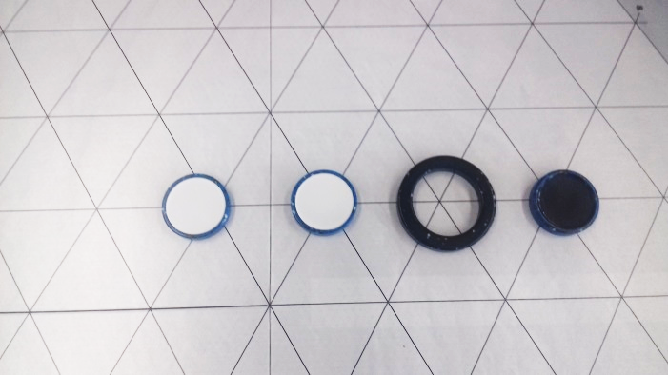
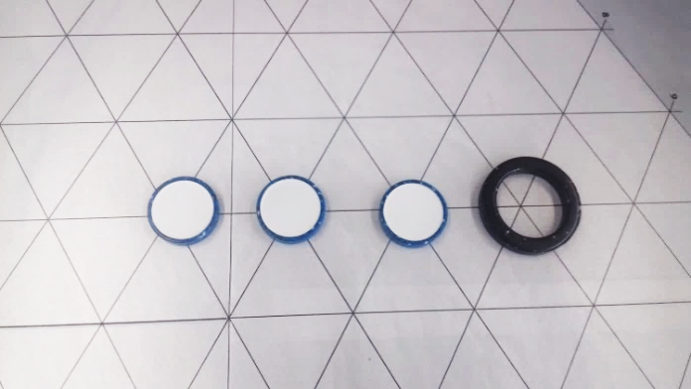
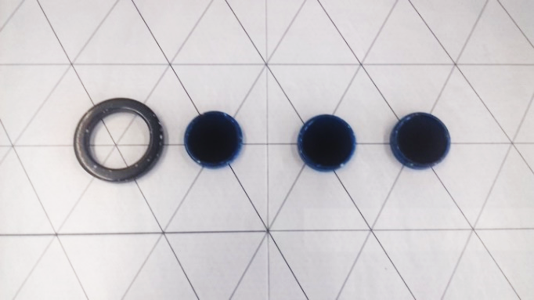
If the row is broken, the ring must finish in the gap
A ring moving over a set of markers, flipping them

Winning the game:
The game is won by moving rings to generate rows of five in your colour, once a row of five has been made:
- You must remove the five markers from the board for re-use.
- Next, remove any one of your rings from the board, place it in one of your ring spaces in the corner of the board. When all three of these spaces are filled, the game has been won.

Special cases:
- If a row of more than five, or intersecting rows, have been generated you can choose five counters to remove (as long as they are all still a consistent row).
- If more than one row is generated (and they don't intersect) both rows and two rings must be removed from the board.
- It is possible to generate a row for your opponent as well, if this happens they must remove their row and a ring after you have finished your turn and before they start their turn.
- If all markers are placed on the board before a player has, the player with the most removed rings wins.

Yinsh – Strategy
Are there certain positions on the board which are the best areas to place your rings?

Is there an advantage to placing your rings on the board first?

How is the gameplay different if you concentrate on only using a few of your rings or try to use all the available rings?

Are there advantages to playing in a defensive manner blocking the other players?

Are there advantages to flipping your own markers?

Is it possible to create a scenario in which you position your rings to be sure the opposing player must give you a row on their turn?

Is trying to gridlock the board ever a good strategy?

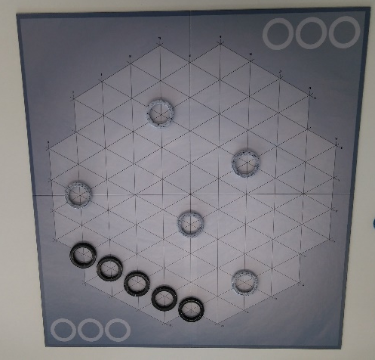
Does the following strategy seem a good idea for a first move?
- Is there a way here that the player using the black rings can be guaranteed the first row?
- Is it possible to change how the player using the white rings places there rings to reduce the opposing player’s chance of creating a row of five?

Blitz Version (Quick Game)
An alternative version of the game is to play using the same rules as before but now the winner is the first player to make a single row of five. This version of the game can also be played using any number of the number of rings chosen by the players.

