Designing calculus tasks to encourage the development of mathematical thinking

Sinéad Breen, Dublin City University, Ann O’Shea, Maynooth University,
Caitríona Ní Shé, Maynooth University and Dublin City University

Corresponding author: Ann.oshea@nuim.ie

Abstract
We report on a task design project in which the first and last authors developed a framework of task types suitable for use in first year undergraduate calculus modules. The task types deemed suitable were: evaluating mathematical statements; generating examples; analysing reasoning; conjecturing and/or generalising; visualising; and using definitions. Using this framework, we designed a series of homework tasks and trialled them in Differential Calculus modules in two institutions. We subsequently used GeoGebra to design interactive versions of some of the tasks and made them available to students via the institutional VLE in one of the universities. Data was gathered from students involved in both trials using interviews and focus groups. In addition, we conducted task-based interviews with students using the interactive tasks. We will focus on a small set of related conjecturing/generalising tasks in this paper and report on some of the findings arising from the evaluative data collected. In particular, we consider the case of Seán for whom there was some evidence of a development in understanding of graph transformations.

1. Introduction
The focus of our initial task design project, conducted by the first and last authors, was the promotion of mathematical thinking skills and habits of mind such as those suggested by Mason & Johnston-Wilder (2004). These include exemplifying, specializing, generalizing, conjecturing, justifying, verifying, and refuting (p.109). Research has shown that the types of tasks assigned to students can influence the kinds of reasoning and thinking processes in which they engage (Jonsson, Norqvist, Liljekvist, & Lithner 2014). A study conducted recently in Ireland showed that the majority of tasks in first year undergraduate calculus modules could be solved with imitative reasoning, that is by memorisation or following a familiar algorithm (Mac an Bhaird, Nolan, Pfeiffer & O’Shea, in press). It is important therefore to develop tasks which give students in these types of courses opportunities to develop higher-order mathematical thinking skills, moving them away from rote-learning.

In a subsequent project, concerning the development of formative assessment techniques in order to improve the teaching and learning experience in first year undergraduate mathematics modules, interactive versions of some of the tasks were developed. The use of technology has a number of advantages: for instance, information can be gathered and processed quickly so that teachers and students can make decisions efficiently to exploit learning opportunities; moreover, the burden of computation can be removed or reduced to allow students to explore and experiment. From a mathematical perspective, Borwein (2005) described specific benefits of the use of technology, including: to gain insight and intuition, to discover new patterns and relationships, to expose mathematical principles through graphs, to test and falsify conjectures, to explore a possible result to see if it merits formal proof, to do lengthy computations. All of these have an important role to play in responding to a conjecturing/generalising task. The interactive tasks designed here are equipped with possibilities for students to receive hints as a means of scaffolding their progression, if necessary, while undertaking the tasks, as well as the option to receive immediate feedback upon completion. (However, these options were not used in the task based interviews referred to later).

Trenholm, Alcock and Robinson (2012) surveyed the literature for evidence of the effect of mathematics e-lectures on student learning (they consider web-based lectures, webcasts, screencasts, or podcasts to be e-lectures). Although many of the empirical studies in the field found that students’ views of the use of technology are generally positive, other studies which used data such as usage statistics, academic records or psychometric data, did not show significant gains in students’ academic performance as a result of using e-lectures. Trenholm et al. (2012) conjecture that although e-lectures may be useful in certain disciplines that ‘the learning of mathematics is better served by a two-way exchange that facilitates for example the flexibility required for advanced mathematical thinking’ (p. 712). In this project, we aim to study how technology can aid this ‘two-way exchange’.
One such way might be to use dynamic geometry software. Breda and Dos Santos (2016) investigated the use of GeoGebra to support first year undergraduate students in the calculation, exploration, visualisation and representation of complex functions. They examined how these tools can enable students to conjecture and provide mathematical proof and recommend they be used to support the study of complex functions. In a study comparing test results of two groups of first year undergraduate students, Takaci, Stankov and Milanovic (2014) found that the group of students who had used GeoGebra while learning about functions were able to solve more hand written test questions than those who did not. In addition, the GeoGebra group of students were quicker in reaching their solutions. In this article, we will focus on the design of a set of conjecturing tasks using GeoGebra and their impact on student understanding.

2. Task Design: Conjecturing and Generalising Tasks

The first and last authors have worked on developing a framework of mathematical task types suitable for undergraduate students (Breen, O’Shea & Pfeiffer (2016)). This framework has six task types: evaluating mathematical statements; generating examples; analyzing reasoning; visualizing; using definitions; conjecturing and generalising. It is the last of these task types that we wish to concentrate on here. The acts of conjecturing and generalizing are well-known to be part of the tools of a professional mathematician (Bass 2015); indeed Bass describes the progress of most mathematical work as starting with exploration and discovery, then moving on to conjecture, and finally culminating in proof. Cuoco, Goldenberg and Mark (1996) speak about encouraging the development of ‘mathematical habits of mind’ in students in order to help them use, understand and make mathematics. They suggest that these habits might include conjecturing, generalising, experimenting, and visualising. These activities are also included in the list of processes which aid mathematical thinking given by Mason & Johnston-Wilder (2004); these authors also discuss ‘natural’ powers that learners possess such as the ability ‘to imagine and detect patterns,..., to make conjectures, to modify these conjectures in order to try to convince themselves and others’ (Mason & Johnston-Wilder, 2004, p. 34). They stress the importance of creating a ‘conjecturing atmosphere’, so that students can participate in inquiry and develop their mathematical thinking skills.

For the last number of years, we have been developing a bank of tasks using the framework mentioned above. Originally these tasks were paper-based and were intended to be used either as written homework assignments or as activities in small-group tutorials. Tasks 1 and 2, shown in Figure 1, are examples of conjecturing/generalising tasks designed for a first year Differential Calculus course.

Tasks 1 and 2 were designed to give students opportunities to explore, spot patterns, and make conjectures based on their observations. We noticed that these tasks proved difficult for some students because of the amount of work they needed to do in order to draw the graphs of the functions mentioned. Some of them made mistakes when doing this and so were not able to generalize or make a conjecture. In 2016, we redesigned these tasks using GeoGebra; we will refer to these as Tasks A and B. The computational burden was thus removed from the students and we hoped that this would allow them more freedom to experiment and conjecture. The use of GeoGebra allowed us to introduce the possibility for students to see the graphs of the form $y=f\left(x\right)+a$ (Task A), and $y=f\left(x+a\right)$ (Task B), for values of a ranging over an interval. Thus, in contrast to the situation in Tasks 1 and 2, students were able to experiment and see what happens if, for example, a is positive or if it is negative. To save space only Task A, Figure 2, is shown below. Both tasks, and others from this project, can be found at http://mathslr.teachingandlearning.ie/GeoGebra/.

Task 1:
- Sketch the graph of $f_{1}\left(x\right)=x^{3}+2$ on its natural domain.
- Sketch the graph of $g_{1} \left(x\right)= \frac{1}{x^{2}}+2$ on its natural domain.
- Sketch the graph of $h_{1}\left(x\right)= 3^{x}+2$ on its natural domain.
- Recall the graphs of $f\left(x\right)=x^{3}$, $g\left(x\right)=\frac{1}{x^{2}}$ , $h\left(x\right)= 3^{x}$. What can you say about the graphs of the pairs of functions $f$ and $f_{1}$, $g$ and $g_{1}$, $h$ and $h_{1}$?
- Can you make a general conjecture from your observations?

Task 2:
- Sketch the graph of $f_{1}\left(x\right)={(x+2)}^{3}$ on its natural domain.
- Sketch the graph of $g_{1} \left(x\right)= \frac{1}{{(x+2)}^{2}}$ on its natural domain.
- Sketch the graph of $h_{1}\left(x\right)= 3^{x+2}$ on its natural domain.
- Recall the graphs of $f\left(x\right)=x^{3}$, $g\left(x\right)=\frac{1}{x^{2}}$ , $h\left(x\right)= 3^{x}$. What can you say about the graphs of the pairs of functions $f$ and $f_{1}$, $g$ and $g_{1}$, $h$ and $h_{1}$?
- Can you make a general conjecture from your observations?

Figure 1: Tasks 1 and 2

3. Task Evaluation: Collection of Data & Results

A selection of interactive GeoGebra tasks designed using the framework above was integrated into a first year science mathematics module at Maynooth University (MU) in the academic year 2016/2017. These tasks were made available to students through the Virtual Learning Environment (VLE), Moodle; use of the tasks was voluntary but some were referred to in the student assignments.

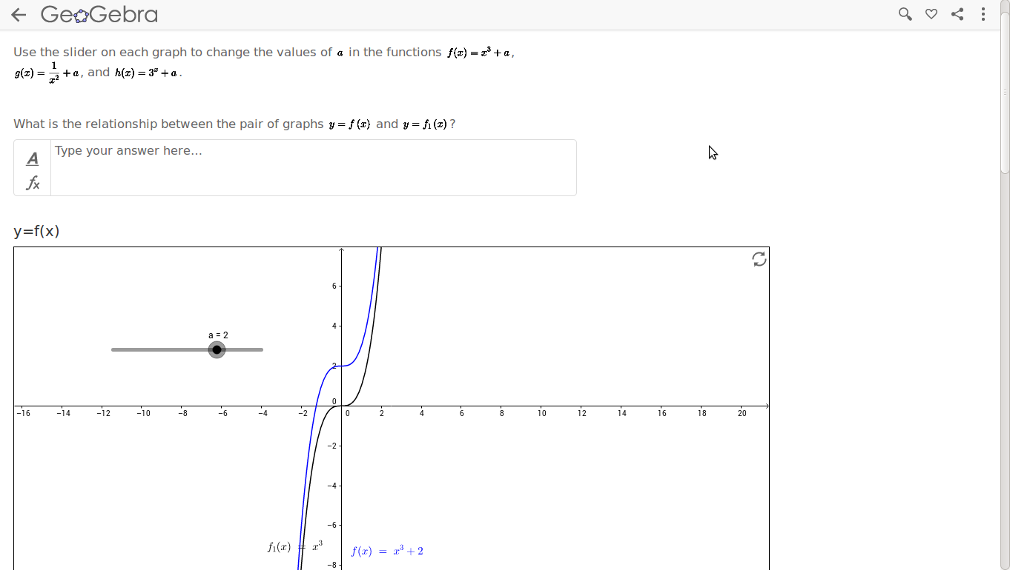

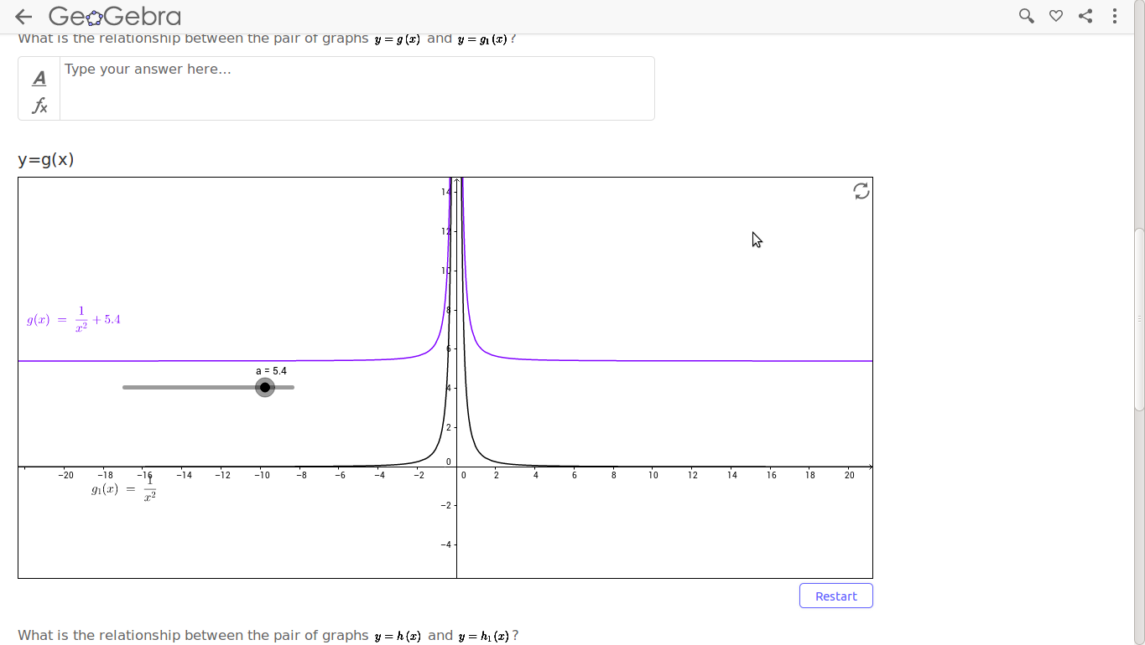

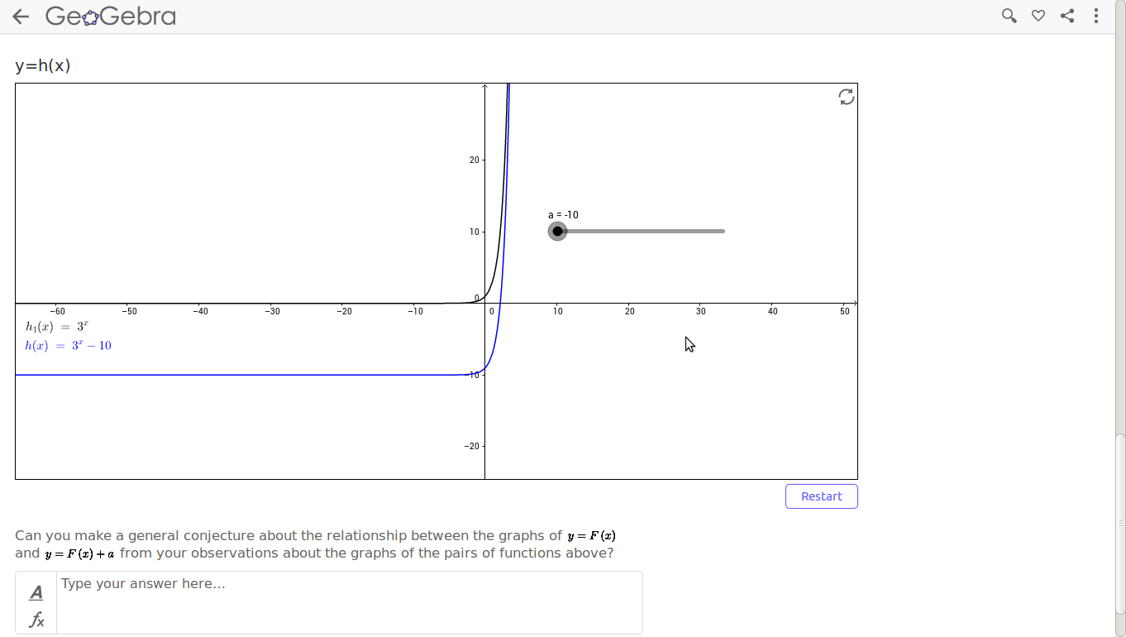
Figure 2: Screen grabs from Task A
Moodle usage statistics for the 396 students enrolled on the module were recorded and a paper based survey (n=220) was administered. As well as gathering background data, the survey asked students to rate the tasks on: their ease of use, the usefulness of particular features, and whether the tasks helped in the development of mathematical understanding. A five point Likert scale, Strongly agree (SA) to Strongly Disagree (SD) was used. This data was analysed in SPSS and excel. About half the respondents to the survey were positive about the effect of using the tasks on their learning; 55% of respondents agreed that the tasks allowed them to better understand key concepts and 49.1% stated that the tasks increased their mathematical confidence, however only 30% of respondents found the tasks easy to use.

Two focus groups, (each of three students), were held in Spring 2017, after the students had received their grades for this module. When asked about the graph transformation tasks the students referred to the fact that they helped with visualization of mathematical concepts. For example, Deirdre said ‘I think it gave me a clearer image of what I was doing, rather than just going with the maths and stuff I had like a visual to go with that as well’. Another student (Gráinne) said that ‘I think that’s actually like really good for seeing things because sometimes I find it hard to imagine what like in your head it just shows how it moves like even from an x cubed plus two to a minus two…’.

In order to further investigate the use and effectiveness of the tasks, the second author carried out a series of task-based interviews with a sample of students from the module. Four students were asked to think aloud while completing a selection of the tasks. A pre and post-test was used in order to help determine if the students’ mathematical thinking had changed as a result of completing the tasks. The interviews, which lasted about an hour, were conducted using a laptop computer and an echo smartpen. Purpose built software, called Recordman, was used to record video, audio, screen and mouse movements. The use of the echopen allowed the electronic recording of student responses to the pre and post test questions. The tasks to be completed by the students were presented to them as a list in a Google document. The relevant text in the document linked, via URL, to the pre and post tests and the various GeoGebra tasks. There were four questions in the pre-test, completed prior to the GeoGebra tasks, and the same four in the post-test. There were seven GeoGebra tasks available to all students. Each student completed between four and seven tasks depending on how quickly they moved through the tasks. Four of the tasks were completed by all four students.

We will consider the responses of the three students who worked on Tasks A and B in the task-based interviews. These students were asked to answer question 4(ii) below before, and again after, working on the interactive tasks.
4(ii) If a is any real number then f(x+a) = f(x)+a for all values of x.
All three got the question right on the post-test but two of the students (Áine and Seán) gave incorrect answers on the pre-test. We will consider Seán’s work on the tasks in some detail as he seems to have developed his understanding of graph transformations while working on the GeoGebra tasks.

3.1. Case Study – Seán

In the pre-test Seán considered a numeric example in order to explain his response to question 4(ii). He started by selecting values for x and a ‘… if x equals one and a equals one …’ and then he calculated the outputs ‘…which means two equals two…’ and finally extends this to every real number ‘…this should also be true for all other values for x and a …’. He only considered this one numerical example.
Seán spent about five minutes working with the three graphs on Task A. He used the slider to examine how the functions changed for the range of values of a. For example when looking at f(x) and f₁(x) he says that ‘…y equals f₁(x) seems to originate from … zero whereas y equals f(x) seems to change its origin to whichever value I set a to be…’ while moving the slider for a through from minus two to plus two. As he moves through the three different functions (f(x), g(x), h(x)) Seán determines that the same thing is happening to the function when he varies a and states that they are ‘…similar to the first one…’. When asked, at the end of the task, to make a general conjecture Seán said ‘…when a is greater than zero the graph… all the graphs shift upwards in the y direction by … whichever value a is from the original position of y equals f(x)’.
Seán worked through Task B in a similar manner for about 6 minutes. He explored how the functions changed by varying the value of a, using the slider, and remarked on how the second and third functions changed in a similar pattern to the first. He said, ‘For h(x) it’s a similar story in that … when I set a, for example .. to be plus five h(x) .. moves to minus five in the negative y direction…’. When asked to give a general conjecture Seán gives a response immediately without having to scroll back up through the three functions, as he did for the general conjecture in Task A. He states that ‘…when a is greater than zero the graph moves in the negative x direction and when a is less than zero the graph moves in the positive x direction and when a is equal to zero the graphs stay the same …’.
When Seán completed the post-test question 4(ii) he immediately stated that his original response was incorrect. We can see from his response (Figure 3) that Tasks A and B seem to have influenced his answer and new understanding.
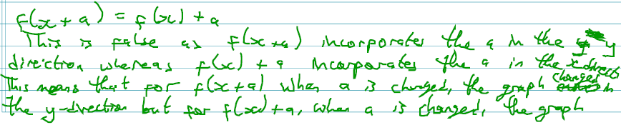
Figure3: Excerpt from Seán’s answer to Q4(ii) in the post-test.

Finally, at the end of the interview, Seán was asked if he considered any of the tasks helped him respond to the post-test questions, he said that Task A and Task B did. He said ‘Yes, … with the f x plus a and f x plus a within the brackets it … helped me to see and distinguish the differences in changing the values of a because I didn’t fully grasp what it was in the beginning…’. When he was asked why he had originally said the statement in 4(ii) was true Seán said that he had taken it (f(x)) as ‘a set function rather than an arbitrary function’. Seán also commented on the value of the tasks for visualisation. He said ‘I guess it helped to show like …it is always good to be able, especially with maths problems to visualise it and GeoGebra with functions just to be able to see what it is is half way, half of the work already done.’

4. Discussion

The questions that we wanted to study in this project were: What are the benefits of using technology in task design?; How effective are the resources that we have developed in developing mathematical thinking skills?. In this article we have only presented evidence from one student who worked on a pair of conjecturing/generalizing tasks. However, from this case study, we can draw some conclusions for the student’s learning. Firstly, it is clear from Seán’s interview that GeoGebra took away the burden of computation; if we had asked him to draw the graphs of the three pairs of functions in Task 1 by hand, then it would probably have taken him a long time and he may have made mistakes. Also, he would have had some information then on the relationship between the graphs of $y=F(x)$ and $y=F\left(x\right)+2$, but not on the relationship between the graphs of $y=F(x)$ and $y=F\left(x\right)+a$ for other values of a. The use of the sliders in GeoGebra, allowed Seán to watch how the graphs changed as the values of a changed, and he was then able to spot the pattern and then make a conjecture. This corresponds with Borwein’s (2005) description of how mathematicians use technology in their own work, and we conjecture that giving students the opportunity to use technology in this manner might encourage them to develop mathematical habits of mind (Cuoco et al. 1996) and thinking skills. Furthermore, in the pre-test Seán seems to see Q4(ii) as referring to a single function, but in the post-test he immediately recognizes that it is a general statement. We conjecture that it is his experience of working on Tasks A and B that accounts for this change in perspective and note that the ability to appreciate the distinction between an instance and a generality is crucial in the development of mathematical thinking.
We have also seen that Tasks A and B helped Seán visualize the graph transformations and he felt that this visualisation was very useful to him. The use of software like GeoGebra makes visualisation more immediate for students and we posit that this can help with engagement. We saw, probably because of the ease of visualisation in Tasks A and B, that Seán felt comfortable in making a conjecture, and so there is evidence that these types of tasks can help create the ‘conjecturing environment’ advocated by Mason & Johnston-Wilder (2004). An added benefit to using technology in the form of these interactive tasks is that they allow students to work at their own pace.
It is interesting to note that the results of the questionnaire administered to the whole class showed that the majority of students reported some difficulties with the tasks and many did not think that they were useful. However we have seen here that when working on the task in an interview situation, Seán seemed to develop understanding. It would be illuminating to study whether students would benefit from some scaffolding for these tasks, or from working on them in a tutorial setting rather than independently. It may be that more work needs to be done to develop the ‘two-way exchange’ suggested by Trenholm et al. (2015).
We have found some evidence that the conjecturing tasks described here can encourage students to experiment and explore. We note that Bass (2015) sees this exploration as the first step in most mathematical work, and therefore it seems like a necessary skill that students should develop in order to improve their mathematical thinking. With this aim in mind, we hope to continue to design and evaluate tasks of this type.

Acknowledgement: This project was funded by Nairtl and The National Forum for the Enhancement of Teaching and Learning.

References
- Bass, H. (2015). Mathematics and Teaching. Notices of the American Mathematical Society, 62(6): 630-636.
- Borwein, J.M. (2005). The experimental mathematician: The pleasure of discovery and the role of proof. International Journal of Computer for Mathematical Learning, 10: 75-108.
- Breda, A.M. and Santos, J.M.D.S.D., (2016). Complex functions with GeoGebra. Teaching Mathematics and its Applications, 35(2):102-110,
- Breen, S., O’Shea, A., and Pfeiffer, K. (2016). Students’ Views of Example Generation Tasks. Teaching Mathematics and its Applications, 35(1): 27-40.
- Cuoco, A., Goldenberg, E.P. & Mark, J. (1996). Habits of mind: an organising principle for mathematics curricula. Journal of Mathematical Behaviour, 15, 375-402.
- Jonsson, B., Norqvist, M., Liljekvist, Y. and Lithner, J. (2014) Learning mathematics through algorithmic and creative reasoning. The Journal of Mathematical Behavior, 36: 20-32.
- Mac an Bhaird, C., Nolan, B., Pfeiffer, K. and O’Shea, A. (in press) A Study of Creative Reasoning Opportunities in Assessments in Undergraduate Calculus Courses. Research in Mathematics Education.
- Mason, J. and Johnston-Wilder, S. (2004) Designing and using mathematical tasks. St Alban’s: Tarquin Press.
- Takači, D., Stankov, G. and Milanovic, I., 2015. Efficiency of learning environment using GeoGebra when calculus contents are learned in collaborative groups. Computers & Education, 82: 421-431.
- Trenholm, S., Alcock, L., and Robinson, C. (2015). An investigation of assessment and feedback practices in fully asynchronous online undergraduate mathematics courses, International Journal of Mathematical Education in Science and Technology, 46(8): 1197-1221.

Captions:
Figure 1: Tasks 1 and 2
Figure 2: Screen grabs from Task A
Figure3: Excerpt from Seán’s answer to Q4(ii) in the post-test.

