Evidenced-based decision making in mathematics support

Anthony Cronin, University College Dublin, Ireland
anthony.cronin@ucd.ie

Abstract
How can busy mathematics support centres (i) offer effective and efficient support to the ever diversifying cohorts of students availing of such support and (ii) help to develop students as independent learners rather than remain reliant on maths support throughout their university careers?
In this talk I will discuss a number of evidence-based decisions made at the UCD Maths Support Centre (MSC) in the last year. These include
(1) why a thorough investigation of the numbers and nature of visits from students registered to stage 3, 4 and from postgraduate students receiving support was initiated,
(2) why we decided to withdraw the MSC service from these cohorts,
(3) why we chose to close the MSC service at exam time,
(4) why we decided to offer later opening hours for specific cohorts, and
(5) why we decided to implement a formal MSC-Module Coordinator Partnership Agreement with lecturers of large first and second year classes.

1. Introduction
While the prevalence of mathematics and statistics support facilities at university level continues to grow it is timely to reflect and ask pertinent questions such as (i) is the service still supporting the students it was originally set up to support, (ii) are there trends we should be aware of so we can modify the service, and perhaps most crucially (iii) do we have adequate evidence to justify making such decisions?
The UCD MSC has been in existence since 2004 when it was initially set up to help students from non-core mathematics courses such as in arts, engineering, science and agriculture. The first three years of opening saw average annual visits of 588 whereas the average number of annual visits from 2013-2016 was 5,589.

1.1. Breaking point
In the opening five weeks of the 2015/16 academic year the reputation of MSC had reached a critical juncture. Despite having negotiated an increase in funding for both extra tutors and extra opening hours the previous term, the number of visits and diversity of those visitors’ queries had reached breaking point. Typically the MSC is staffed by 3-4 tutors at any given time from the hours of 10am-7pm Monday through Thursday and by two tutors on Fridays from 10am-1pm. For an excellent paper on rostering a sufficient number of relevantly skilled staff at busy periods in a maths support centre please see Gillard, Vile, Knight and Wilson (2016).
The total number of modules from which students presented at the MSC during this fiveweek period was 105 with 51 of these modules delivered by the School of Mathematics and Statistics. Table 1 below shows the number of MSC visits for the first five weeks of the first term of 2015/16.

[Insert Table 1: MSC data for student visits in weeks 1-5, Semester 1, 2015/16]

Week # | 2015/16 | 2014/15 | % Increase
1 | 15 | 2 | 650%
2 | 132 | 35 | 277%
3 | 287 | 255 | 13%
4 | 300 | 224 | 34%
5 | 303 | 282 | 7%
Totals | 1,037 | 798 | 30%
Table 1: MSC data for student visits in weeks 1-5, Semester 1, 2015/16

During one of my regular shout outs at a relevant lecturer’s class during week 4, a mature student put her hand up to say “while I have no doubt that the MSC service is an excellent one I have been in there three times in the past two weeks and have had to leave on each occasion as a tutor never got round to me in the time I had allocated to my maths support visit”. Been confronted with such a serious issue while trying to advertise the benefits of accessing a maths support centre to a large first year class is extremely troubling.
These events culminated in a emergency meeting of the Maths Support Centre Oversight Committee, which includes the MSC Director, the Head of the School of Mathematics and Statistics (the largest school in the university) and representatives from statistics and applied mathematics.

2. Evidence-based decision making
With the data management system the student logs in to the system with their student number and is placed in the electronic queue. This allows us to accurately record the time that a student waits before they are assisted by a tutor.
The tutor also pauses the student’s session when they leave that student to assist another table before returning to that student at a later stage. This again allows us to determine exactly how much time a student actually spends one-on-one with a tutor and how much of their time is spent paused working alone. For a full walkthrough of the UCD MSC data management system development see Cronin and Meehan (2015).

2.1. Restriction to first and second years only
Figure 1 below for example shows that over 400 visitors waited between 0-10 minutes to be seen for the first time by a tutor. While some 300 visitors were waiting between 20-60 minutes to be seen initially. A total of 24% of these visits were from students registered to level 3 or level 4 modules or postgraduate students. Feedback from MSC tutors revealed that a significant number of visits from later stage students (postgraduates and final year degree students) required the tutor to read through a large data set for a project before deciding on the most appropriate course of action which was very time consuming.

[Insert Figure 1: Wait times for MSC visitors in 10-minute intervals]
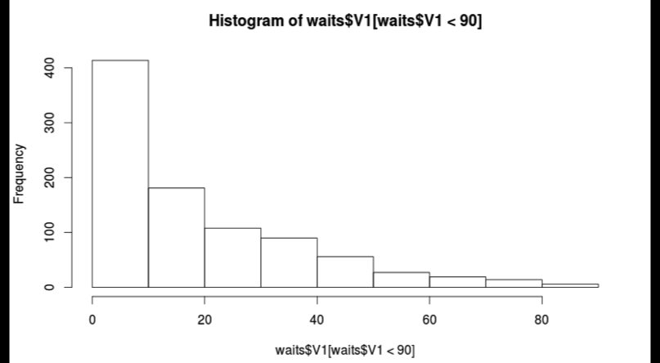
Figure 1: Wait times for MSC visitors in 10-minute intervals

The total amount of time (including the pauses) spent with a tutor for each visit is shown in Figure 2 below. For example over 200 of the MSC visitors are only spending 0-10 minutes with a tutor which may include a pause. On average these visitors are waiting approximately 30 minutes for this ten-minute window of assistance.
[Insert Figure 2: Time spent with tutor for MSC visitors in 10-minute intervals]

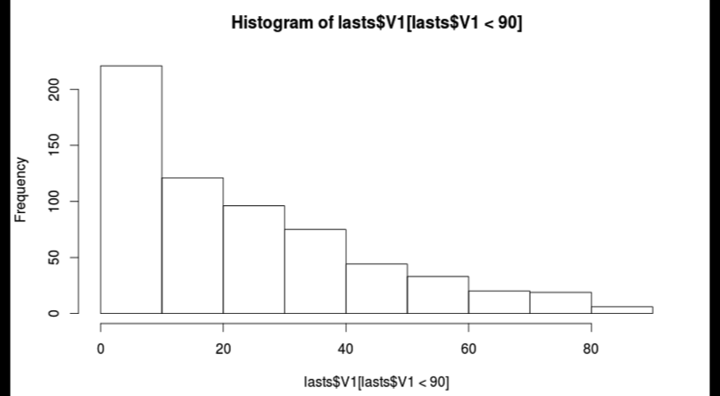

Figure 2: Time spent with tutor for MSC visitors in 10-minute intervals
A thorough investigation of both the “waiting times of visitors” and the “time spent with a tutor” statistics was conducted on students registered to year 1 or 2 of their studies versus students in the their third, fourth or postgraduate years of study (see Figures 3 and 4 below). This revealed that just 36% of a first year student’s time in the MSC is spent with a tutor and a large cohort (41%) of these students were waiting over 30 minutes to be seen by a tutor.
[Insert Figure 3: Average time spent with a tutor]

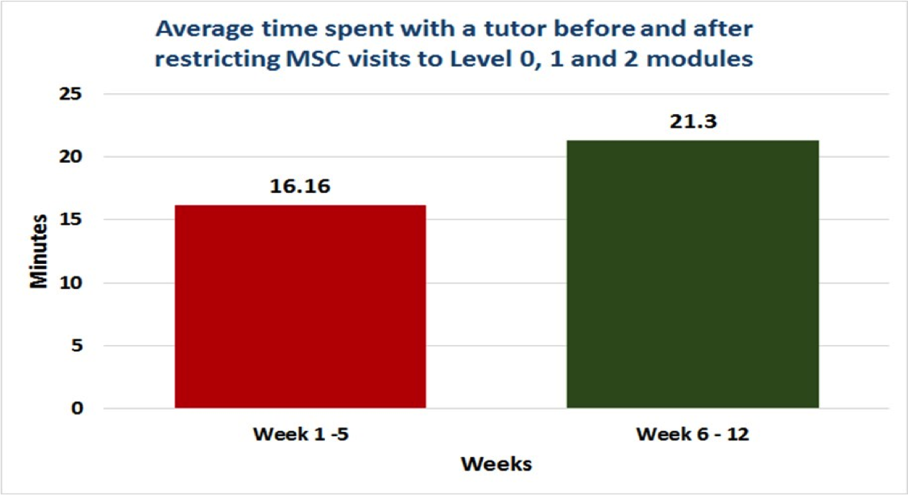
Figure 3: Average time spent with a tutor

[Insert Figure 4: Average wait time for a first or second year student]

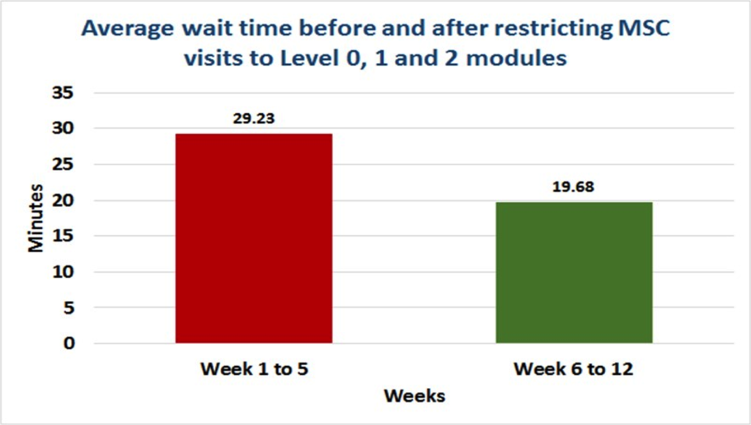
Figure 4: Average wait time for a first or second year student

By removing approximately 25% of all MSC visits i.e. the visits from level 3, level 4
and postgraduate students which were accounting for a disproportionate amount of
tutor time, the MSC has reduced its waiting time for its visitors by one third (a ten
minute reduction in waiting time, see Figure 2) and increased the time spent with
a tutor from 16 minutes to 21 minutes (see Figure 1).

While changing the terms of service of student support in the middle of the first semester of university study is not to be taken lightly, having examined the trends presented above it was decided that by restricting the service to first and second years only the maths support centre could continue to offer quality support to the students most in need of it.
We presented these facts to the Registrar and Vice-president of the University who has ultimate responsibility for the Maths Support Centre and the decision was taken, in consultation with the UCD Students’ Union education officer who fully supported it, to offer the MSC service to students registered to level 0, 1 or 2 modules only from then on.
Crucial to making such important and potentially impactful decisions on the nature of support to be offered by an institutions maths support service is the software system that allows such accurate and comprehensive data to be gathered and analysed. This system synchronises with the institutions central registry system which records all the relevant registration information for each student in the university. Students at UCD have up to the end of week four to change their programme or modules and then they must complete an internal transfer document all of which means it can take up to week seven of term before we know what modules and programme a student is registered to; so having access to the most up to date registration data is critical to maintaining accurate data records.

2.2. Closing during exam time
An anlaysis of the 2015/16 data showed that the number of first time visitors to the MSC in the revision and examination weeks (weeks 13-15 of each semester) of semester one and two was 212 and 90 respectively. This represents 20% and 15% of all visitors to the MSC for these semesters respectively.
In 2015/16 the number of visits in the revision and exam weeks was 1,280, (710 in semester one and 570 in semester two), representing 23% of all MSC visits for that year.
An analysis of the MSC tutors’ feedback comments from these periods show that 86% of the comments are directly related to students asking for help with exam questions. Part of most maths support centres’ mission is to promote students to engage in deep, self-directed learning and not to promote a last minute surface learning approach.
These facts allowed us to make the justified decision of closing the MSC face-to-face service during the examination weeks of both semesters and re-direct the tutor expenditure saved during these periods to further bolster in-term support.

2.3. Later opening hours
Using an analysis of the academic timetables and times at which Engineering and Science students visited the MSC and incorporating feedback from a survey of both MSC users and non-users in the summer 2016 the MSC made the decision to extend the opening hours to include 5-7pm slots from Monday to Thursday. To accommodate this implementation resources were moved from other parts of the MSC opening hours (e.g only 1-2 tutors were on duty for some lunch hours). Experience has shown that apart from the obvious in flux of visits from students about to complete mid term exams (weeks 5-7) and final exams (weeks 11-13) it is very difficult to predict busy times as timetables, teaching staff, tutorial resources and module assessment structures among other issues can change each year.

2.4. MSC-MC partnership agreement
In September 2016 the MSC management initiated the Maths Support Centre- Module Coordinator Partnership Agreement. This involves MSC management meeting individually with lecturers from modules which present a significant number of MSC visits prior to each teaching semester resuming. An example of the questions asked and the agreement sought are included in Appendix A. An example of the feedback data on an individual module’s content is presented in Appendix B.

3. Conclusion
Offering the most effective and efficient mathematics support for our students is becoming more of a challenge as the number and variety of students accessing such support continues to grow. The recording and analysis of accurate data is crucial to implementing decisions that can have major impact on our students’ learning. Obtaining access to the most up-to-date student registration records ensures that capturing relevant data for maths support purposes leads to informed and evidenced based decision making.
Further research is required to target the students who are most in need of mathematics and statistics support and indeed to investigate what it is that students get from maths and stats support (other than the obvious benefits of one-to-one tutelage) that is not offered to them within their traditional learning formats of lectures and tutorials. For our part increases in the visits to the UCD computer science support centre, CSTAR the Centre for Support and Training in Analysis and Research, and the recent establishment of an economics support centre whose visits primarily emanate from students studying mathematically based modules from final year students are all welcome developments that have helped ease the pressure on the UCD maths support centre.

1,950 words

References
Cronin, A., Meehan, M. (2015). The development and evolution of an advanced data management system in a mathematics support centre. Proceedings of the CETL- MSOR Conference 2015: Sustaining Excellence, London, UK, 21–27.
Gillard, J., Knight, V., Vile, J. and Wilson, R. (2016). Rostering staff at a mathematics support service using a finite-source queueing model. IMA Journal of Management Mathematics 27 (2), pp. 201-209.

Appendix A
Maths Support Centre-Module Coordinator Partnership Agreement – MATH101** 2016/17

Do you object to students from MATH101** attending the MSC? Yes No
If not what level of support do you want the MSC to provide?
Details:

Do you object to these students attending the MSC during the revision period? Yes No

Do you want me to attend a lecture to advertise the MSC? Yes No
When -
Where -

Will you put up a slide/announcement in the first week of lectures (and on Blackboard/Moodle) advertising the MSC and how you want your students to use it in terms of assignments, lecture material, notes etc? Yes No

Do you agree to set up the MSC manager as a student on your Blackboard/Moodle page for access to the module’s material? Yes No

Can you provide the MSC with (approximate) dates of the midterm, CA due etc?
Details:

Do you agree to meet at the end of the semester to review this policy and discuss your next semester module(s)? Yes No

Policy: If you agree to the above, the MSC will ask you to engage with the MSC feedback mechanism i.e. you will be sent a weekly email on Fridays at 2pm with details of the visits to the MSC from module MATH101**.

If a significant proportion of students from this module attend the MSC in a given week the MSC manager will inform the Module Coordinator of the issue.
If these visits continue the manager will inform the Module Coordinator again and if the issue persists we will agree on how to proceed regarding support from the MSC for this module.
The manager will ask the Module Coordinator to inform their students of this.

Signature:
MSC manager - Anthony Cronin

Signature:
MATH101** Module Coordinator – A Lecturer

The Process

Early September and January- MSC manager meets Module Coordinator to discuss MSC feedback from previous year and plans for the year ahead.

Same meeting - MSC manager runs through MSC-Module Coordinator Partnership Agreement form and discusses any issues arising.

MSC manager and Module Coordinator (MC) agree on the partnership document and both sign the MSC policy agreement.

A copy of the signed agreement will be forwarded to the MC after this meeting.

Appendix B
MATH101**- Linear Algebra for ******* 2015/2016 Semester 1

Number of MSC visits: 183
Number of unique students that visited the MSC: 65
Number of students sitting the December exam: 289
Number of students failed the December exam: 41

MSC Visits Summary

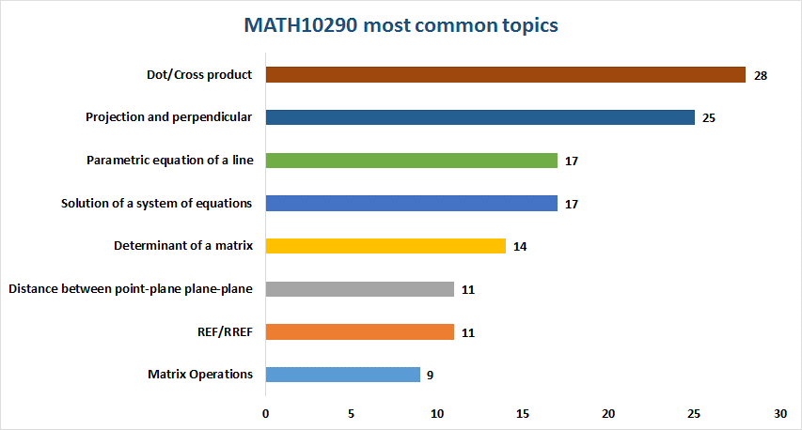

During the first weeks of the semester the majority of students that attended the MSC asked questions relating to solving systems of linear equations using Gaussian elimination. A lot of them were asking about elementary row operations (ERO’s) when taking a matrix to reduced echelon form (REF) and reduced row echelon form (RREF) and how these two forms are different from each other. Most mistakes happened carrying out the arithmetic operations. Some students came looking for an algorithm to follow in order to reduce a matrix.

The next most common trouble-spot was recognizing free variables and leading variables in a matrix after it has been reduced to RREF. They were failing to understand what it means for a system of equations to have a unique solution, infinitely many solutions or no solutions. Converting the bottom row back to an equation after the augmented matrix has been reduced seems to help them follow these concepts.

This also leads to problems when they were asked to express the general solution for a system of equations. This particular topic was very frequent in the MSC visits. Students were finding it confusing to provide a parametric solution for a system of equations and especially how to write it in vector form. There were a lot of students who were also able to get the right answer but failed at submitting it to Blackboard/Webwork.

The main problem with matrix operations was the matrix product although with a bit of practice they seem to follow the method.

Students seem to struggle with the properties of matrix multiplication and definitions in order to follow or complete proofs and solve exercises (e.g. if $AX=B$ then$X=A^{-1}B$ was a common question). A lot of the questions were about finding the inverse of a matrix using EROs and using the adjugate matrix method, the definition of an identity matrix and the definition of an inverse$A^{-1}*A=I_{n}$. They usually think of the definition of an invertible matrix as a matrix with a determinant different than zero and not the proper definition.

Later on in the semester there was an increase of students asking about vectors. They seem to struggle with the equation of a line in 3D and its difference from the equation of the plane. They were having problems in understanding the parameterization of a line in 3D. This causes trouble when they need to identify a plane or a line in 3D.

Intersection of planes is another trouble-spot for students. They fail to relate the exercises to their visual representation and therefore not understanding the solution they are getting to these questions. In the MSC they were encouraged to use sheets of papers as planes and pencils as lines. Using this method seems to help them realize that two planes intersect at a line or that “a piece of paper and a pencil” intersect at a point and helps them understand the answers they compute. It also helps them to visualize what happens when there is no intersection and how this would look like.

The dot/cross product was the main topic covered in the MSC. Most students were able to compute the products but were lacking the visual representation of them. They failed to remember that the cross product is perpendicular and this causes some problems when they are trying to find the equation of a plane.

Another common topic covered during the semester was projections and perpendicular distances between two vectors, in particular their visual representation. They use these concepts to calculate distance between 2 parallel planes, a point and a line, a point and a plane or a line and a plane. Since they struggle with the graphical representations of projections and perpendiculars in 3D they have trouble understanding the formulas used.

Other common topics include:
- Why parameterize a solution to a system of equations?
- How to recognize what represents a line or a plane in 3D.
- When is the product/sum of matrices defined?
- Finding parallel vector to 2 planes
- Meaning of the dot product between 2 vectors being zero
- Finding the equation of a plane knowing 3 points that belong to the plane.

Details of all 183 MSC visits follow below (omitted)

