Using a spreadsheet to encourage Mathematical thinking and problem solving – an Irish perspective
Robert J. Loughnane, FIMA, CMath,
Galway Business School and The Galway Study Centre, Galway, Ireland

Abstract
The purpose of this research paper is to investigate the effectiveness of using specialised spreadsheet modelling algorithms to encourage the development of mathematical thinking and problem solving skills with second and third level students in Ireland. We developed and subsequently tested a number of such spreadsheet modelling algorithms with various second level and third level students. A quantitative analysis of the data collected from the testing of these students is presented. Our findings demonstrate that when the students are taught through exposure to the spreadsheet algorithms their Mathematical thinking and problem solving skills are enhanced and this is further reinforced by an improvement in their test results. Furthermore, this study showed that allowing the students to experiment with the algorithms encouraged higher order thinking and problem solving. We feel that the findings in this study will be of interest to educationalists throughout the world.

Key Words spreadsheet algorithms, mathematical thinking, problem solving

1. Introduction
Over the past decade the Teaching and Learning of Mathematics at Second and Third Level has become one of the most challenging problems facing most countries. In fact, many countries have experienced serious problems as regards student retention, participation and performance in Mathematics (Beauchamp & Parkinson, 2008). These serious problems can be attributed to the teacher’s lack of important teaching competencies such as technology enabled teaching, and the innate ability to motivate and encourage students to actively engage in a desire to learn the subject (Ottevanger, van den Akker and de Feiter, 2007). The use of technology as an aid in the teaching of Mathematics is now well established and technology-based tools have been found to be essential in teaching Mathematics at Second Level, since they lead towards a better hi-res graphics depiction, clarification and understanding of the more difficult aspects of the subject (Loughnane, 1988 and Boutskou, 2016). Despite the wealth of studies supporting the use of technology in the teaching of Mathematics at Second Level, spreadsheet use is limited or even non-existent in classrooms in Ireland, primarily because teachers have not been trained or prepared to integrate them as teaching and learning tools. Very few teachers have been trained in the use of spreadsheets as tools for learning mathematics, leaving many of them unprepared to guide students in learning mathematics with spreadsheets (Niess, 2005).

2 Background to new Secondary Level Mathematics Syllabi in Ireland
The Department of Education in Ireland introduced the new ‘Project Mathematics Syllabi’ at both Junior Certificate Level (O Level in UK) and Leaving Certificate Level (A Level in UK). These new syllabi have been slowly phased in since June 2010 with the final changes taking place in June 2015. The new syllabi encourage a more practical approach to the teaching of Mathematics with a major focus on problem solving. The Leaving Certificate Higher Level syllabus consists of five Strands as follows:-
Strand 1 Statistics and Probability
Strand 2 Number
Strand 3 Algebra
Strand 4 Geometry and Trigonometry
Strand 5 Functions and Calculus
We have developed and subsequently tested spreadsheet modeling algorithms associated with Strand 1 and Strand 5. Specifically, we created student friendly modules that address the following important aspects of the syllabus:-
1 Mean and Standard Deviation of Data applied to real ‘data sets’ - Strand 1
2 Linear Correlation and Regression applied to real ‘data sets’ - Strand 1
3 Maxima and Minima and Roots of Cubic Polynomials - Strand 5
We are currently developing further algorithms for Strands 2, 3 and 4 which we hope to have completed in the next 12 months.

3. The essential use of spreadsheets to aid Mathematics Teaching
Spreadsheets offer exciting and dynamic Mathematical modeling capabilities that lead toward their use as a problem solving tool with the capacity for engaging and encouraging students in higher-order thinking skills that supports them in exploring beyond initial solutions (Niess, 2005). Spreadsheets are now readily available in almost every classroom in Ireland and they should be employed by teachers to encourage students to experiment and improve their problem solving skills. However, as already stated, very few teachers in Ireland have been trained to integrate spreadsheets into their teaching and learning pedagogies.

4. Teaching Descriptive Statistics using the FRED Excel Ad-In
The Federal Reserve Bank of St. Louis Economic Data (FRED) Excel Add-In is free software that will allow the student to import realistic ‘data sets’ directly into Excel. The FRED add-in provides free access to over 390,000 data series from various sources (e.g., BEA, BLS, Census, and OECD) directly through Microsoft Excel. The FRED Ad-In can easily be downloaded and installed for the relevant version of Excel being used (Excel 2007, Excel 2010, Excel 2013, Excel 2016). Basically, a new Tab called FRED is included on the main Ribbon. When the students click on the FRED tab they are asked to search for the data they are looking for and it is then imported into the current Excel sheet. We have used this Ad-In to help in the teaching of Descriptive Statistics to Second Level students studying the Leaving Certificate Higher Level Mathematics Syllabus (equivalent to A Level in UK) and also to a group of Third Level students studying ‘Quantitative Methods’ as part a Business Degree.

5. Research Methods
This study examined the effect of using spreadsheet algorithms to encourage the development of Mathematical thinking and problem solving with a number of second level and third level students in Galway, Ireland. Thus, the main research question was as follows:-
How were the students Mathematical Thinking and Problem Solving skills enhanced following exposure to the spreadsheet algorithms
55 Second Level Students (30 females and 25 males) studying the Leaving Certificate Higher Level Mathematics syllabus were chosen at random from local secondary schools in the City and County of Galway. The average age of these students was approximately 17 years. These students attended Leaving Certificate Higher Level Mathematics classes with the author of this paper on a one-to-one basis. These 55 students were essentially made up of 2 groups (Group A – 30 students and Group B – 25 students). A further 30 Third Level Students (16 females and 14 males) who were studying ‘Quantitative Methods’ as part of their Bachelor of Business Degree also took part in the study. These students were made up of two further groups (Group C – 15 students and Group D – 15 students). These students also studied the Mean and Standard Deviation of Data applied to real ‘data sets’, Linear Correlation and Regression applied to business data and Maxima and Minima of Cubic Polynomials. The average age of these students was approximately 22 years.

We used Quantitative Analysis (Hypothesis Testing following a Group Test) and Qualitative Analysis (10 Minute Interview with each student in each Group at the end of the course).

5.1 Quantitative Analysis (Hypothesis Testing – Difference of 2 Means)
The students in Group A were introduced to the concepts by means of effective examples. Each of these students then worked through problems that enhanced the concepts under guidance from the teacher. The students in Group A were taught over a six week period. They covered Mean and Standard Deviation of real ‘data sets’, Linear Correlation and Regression and the Maxima and Minima of Cubic Polynomials. At the end of the six week period this Group were given a test and the average mark attained was 78 with a standard deviation of 10.

The students in Group B were taught with the assistance of the spreadsheet algorithms discussed earlier over a six week period. Each student in Group B were shown how to use the FRED Ad-In and they were also given assistance with any basic problems they had in using the algorithms. The algorithms covered the Mean and Standard Deviation of real ‘data sets’, Linear Correlation and Regression and the Maxima and Minima of Cubic Polynomials. At the end of the six week period this Group were given the same test as Group A and the average mark attained was 85 with a standard deviation of 15. We wanted to test the Hypothesis that there was no difference in the teaching methods used with Group A and Group B.

Null Hypothesis : There is no difference between the teaching methods () Alternative Hypothesis: There is a difference between the teaching methods ()

We used a 2-tailed t-test. Specifically, the approach is appropriate because the sampling method was simple random sampling, the samples were independent, the sample size was much smaller than the population size, and the samples were drawn from a normal population.
At a significance level of 0.10 we found that p = 0.054 and therefore we cannot accept the Null Hypothesis and we conclude that there is a difference between the teaching methods.

Similar teaching approaches were taken with Group C (identical teaching approach to Group A) and Group D (assistance of spreadsheet algorithms) over a 6 week period. At the end of the 6 week period each of these groups were given an identical test and the results analyzed as before using a 2-tailed t test. A table summarizing all of the group test results is given below:-

Table 1 - Summary of group test results
Group | Mean | Standard Deviation | Significance Level | p-Value
A | 78 | 10 | 0.10 | 0.054
B | 85 | 15 | 0.10 | 0.054
C | 60 | 12 | 0.10 | 0.004
D | 82 | 14 | 0.10 | 0.004

The p-Value of 0.004 at a significance level of 0.10 leads us to conclude that there is a difference in the teaching methods used with Group C (identical teaching approach to Group A) and Group D (assistance of spreadsheet algorithms).

5.2 Qualitative Analysis (10 Minute Interview with each student)
In order to gain a more detailed understanding of the efficacy of using the spreadsheet algorithms we interviewed each of the students taking part in the study. The interview questions were designed in such a manner as to discover how the students were thinking Mathematically. We asked the students three questions as follows:-

Question 1
What does the standard deviation of realistic ‘data sets’ actually measure?
Question 2
Give two ‘real life’ examples of the application of linear correlation and regression?
Question 3
How do you feel that the Maxima and Minima of Cubic Polynomials could be applied in the areas of Science, Engineering or Business?

While this approach is neither exhaustive nor quantitative it does give an indication of how the students are thinking from a Mathematical standpoint. When we analyzed the responses given we discovered that those students in Group B and Group D displayed a better understanding of how the Mathematics under investigation could be applied to ‘real life’ problems. We believe that this is mainly due to the fact that these students were allowed to experiment with the spreadsheet algorithms under appropriate guidance from the teacher.

6. Results
The students understanding of the Mathematical concepts and how they were encouraged to think Mathematically is illustrated in the Figures shown below:-

Mean and Standard Deviation applied to real ‘data sets’
The students used the FRED Ad-In to import the harmonized unemployment rate of all persons in Ireland from 1981 to 2011. This data was stored in an Excel sheet and the students explored the mean and standard deviation. The students first plotted the data and computed the mean and standard deviation for the complete ‘data set’. They then noticed that between 2000 and 2007 that the employment rate had significantly reduced (Ireland was experiencing the Celtic Tiger Years). The students re-plotted the sub-set from 2000 to 2007 and then re-computed the mean () and standard deviation () and found that both had reduced significantly. The graphical representations and analysis that the students carried out are shown in Figures 1 and 2 below.

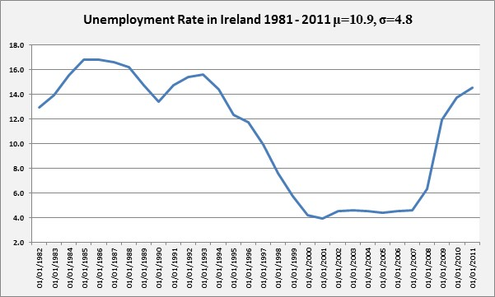
Figure 1: Mean and Standard Deviation of Unemployment Data Set

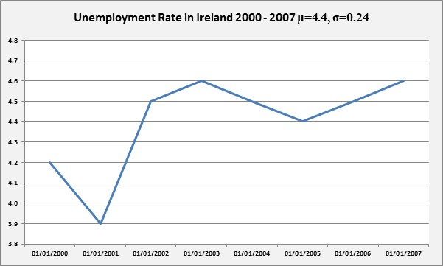
Figure 2: Mean and Standard Deviation of Unemployment Data Set

It is clear that the students really got to grips with the real meaning of the Mean and Standard Deviation applied to real ‘data sets’. By using the FRED Ad-In the students were easily able to import and analyse other realistic ‘data sets’.

Linear Correlation and Regression applied to real ‘data sets’
The students again used the FRED Ad-In to import the Real Residential Property Prices for Ireland and The UK for the years 2006 to 2016. They then produced a scatter plot of the data and computed the linear correlation coefficient (r) and corresponding regression equation y = a + bx as shown in Figure 3.

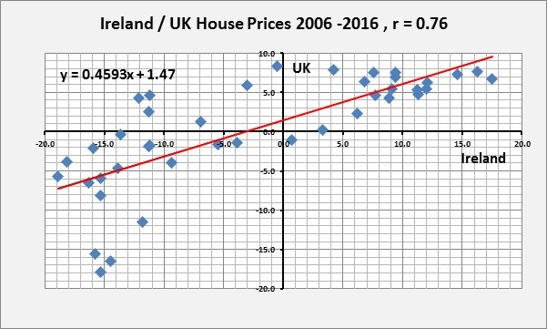
Figure 3: Linear Correlation and Regression of Ireland / UK House Prices

The students used the FRED Ad-In to import many other ‘data sets’ and then performed Linear Correlation and Regression Analysis. This enabled the students to get a better understanding of the meaning and application of Correlation and Regression.

Maxima and Minima of Cubic Polynomials
The value of the variables a, b, c and d (coefficients of the cubic polynomial) were stored in Cells B1, B2, B3 and B4 of an Excel Sheet. The students could then easily change values of these variables and see the effect upon the Maxima and Minima and the nature of the roots. The spreadsheet algorithm helped the students to understand that when a cubic polynomial of the form has Maxima and Minima of different sign then there will be three real roots. However, when they vary the value of d the polynomial has only one real root (Figure 4).

Max and Min of different signs - leads to 3 real and distinct roots
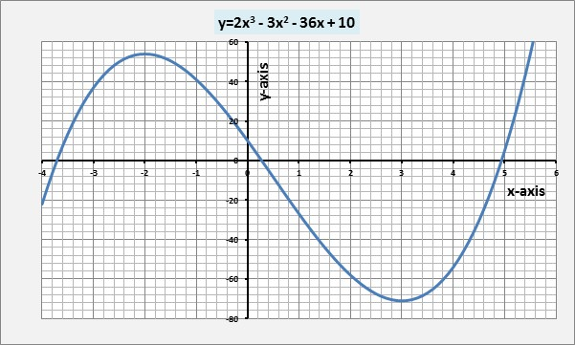

Max and Min are both positive - leading to only one real root
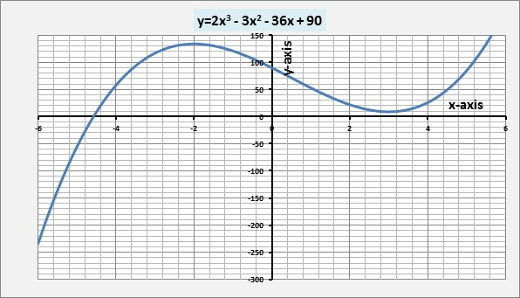

Max and Min are both negative - leading to only one real root
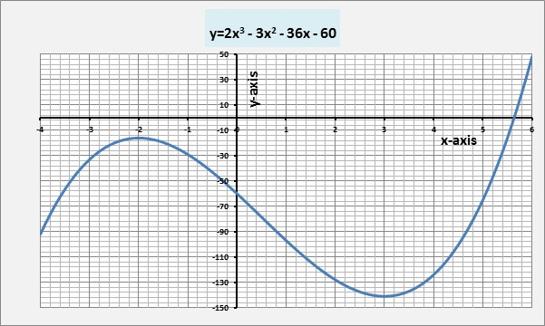
Figure 4: Maxima and Minima and roots of Cubic Polynomials
It should be noted that the students were encouraged to determine the Maxima and Minima Turning Points before experimenting with the algorithm.

7. Discussion and Conclusion
It is very clear from the quantitative and qualitative analyses carried out that exposing the students to the spreadsheet algorithms not only improves their test results but also enhances their Mathematical thinking. In particular, the use of the FRED Ad-In allowed the students to import real business data (house prices, unemployment data, GDP data, wages and salaries data) directly into their excel sheet and then analyze it. We believe that when students are applying Mathematics and Statistics to real data sets they gain a better understanding of the generic Mathematical and Statistical thinking process.

We also believe that the teacher plays a pivotal role in the success of using these spreadsheet algorithms to enhance the Mathematical Thinking and Problem Solving skills of students. We further believe that every Mathematics teacher must be encouraged to introduce spreadsheets into their teaching and learning pedagogies. Students should be taught the basic Mathematical concepts and then be encouraged (with some direction from the teacher) to explore further through the use of the spreadsheet algorithms. It is this further exploration that enhances the students Mathematical Thinking and Problem Solving Skills.

Further spreadsheet algorithms will need to be developed and tested with many more second level and third level students before any concrete conclusions can be drawn from this research. However, we are confident that the use of spreadsheet algorithms that include the FRED Ad-In does encourage the development of Mathematical Thinking and Problem Solving with Second and Third Level students.

8. References
Beauchamp, G. and Parkinson, J. (2008). Pupils’ attitudes towards school science as they transfer from an ICT-rich primary school to a secondary school with fewer ICT resources: Does ICT matter? Education and Information Technologies, Vol. 13: 103-118.

Boutskou, L. (2016) Using Graphics Calculators in Mathematical Teaching: Perceptions of Secondary Education Teachers. Journal of Regional & Socio-Economic Issues. Special Issue, Vol. 6:42-61.

Loughnane, R.J. (1988) Teaching Mathematics through the Medium of High Resolution Graphics. International Journal of Mathematical Education in Science and Technology, Vol. 19 (No 2):319-330.

Niess, M. L. (2005) Preparing teachers to teach science and mathematics with technology: Developing a Technology Pedagogical Content Knowledge. Teaching and Teacher Education, Vol. 21:509-523.

Ottevanger, W., van den Akker, J. J. H. and de Feiter, L. (2007). Developing Science, Mathematics and ICT education in Sub-Saharan Africa (SMICT): Patterns and promising practices, World Bank Working Paper (101):1-84.

