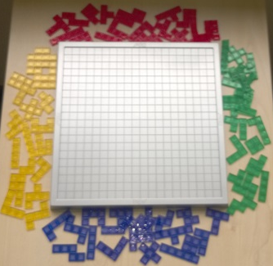
Blokus – How to Play
Estimated play time: 20 minutes
Players: 2-4

Blokus is a 2-, 3- or 4-player game where the aim is to have the lowest number of squares left in your reserve, not played on the board.

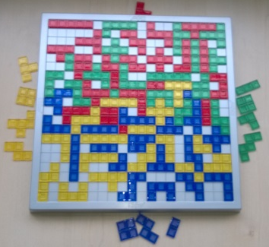

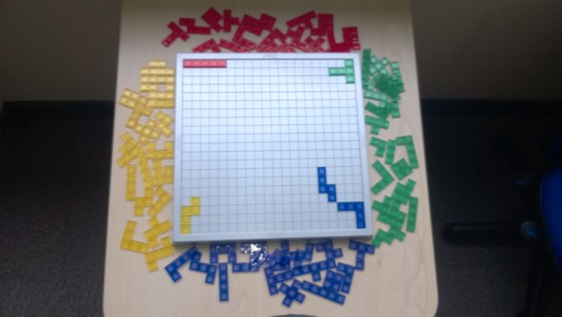
On each turn a player places a piece of their colour corner to corner with other pieces. This starts from a player’s corner of the board, with the piece covering the corner square.

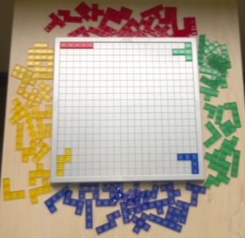

In 4 player games, every player has one colour to themselves. In the case of a 3-player game the remaining colour is shared between the players, who take turns to place the colour as if it was a fourth player. 2-player games split the colours with each player having 2 each. The colours are played in the order: blue, yellow, red, green.

There are no limitations to how a piece is played around an opponents as long as your own pieces only touch via the corners. When the game has ended each player loses a point for every square of the pieces they have left. They also gain 15 points if all pieces are played and 5 more if the unit square was played last.

Blokus – Strategy
Do you want to head towards the middle of the board or keep to the edges at first?

Is it better to place your straight lines pieces quickly?

Do you want to focus on spreading in one direction or many?

What pieces are better to use in blocking your opponents movement?

Want to look further? Look at tiling or bin packing.

