Callisto – How to Play
Estimated play time: 30 minutes
Players: 2-4

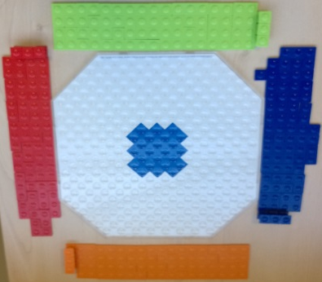
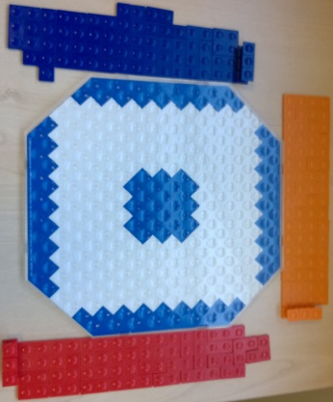
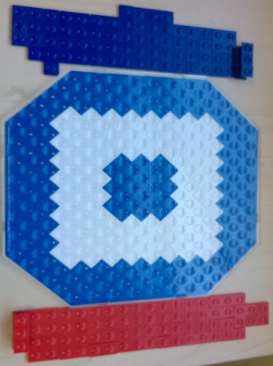
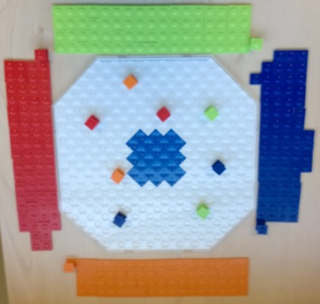
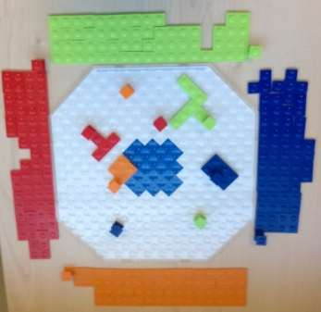
Each player picks a colour to play with and takes all of the columns and tiles of that colour. The board changes depending on the number of players. For the 2- and 3-player games the dark outer area cannot be played on, while on all games columns cannot be placed in the dark centre section. On each player’s first 2 turns they must play 2 of their 3 columns, anywhere on the board, then they can play columns or tiles from then on.
Callisto is a 2-, 3- or 4-player game where the aim is to play as many of your pieces as possible on the board. The winner is the player with the least tile space remaining in their reserve.
Any tiles played have to be placed adjacent to other tiles or columns of the same colour, columns however can be played anywhere outside of the centre section.

When no pieces can be placed, each player must count the number of squares the pieces they have left could cover. The player with the lowest number wins.

Callisto – Strategy
When placing your first 2 columns do you want to keep them close together or far apart?

What pieces are better to use in blocking your opponents movement?

Do you want to focus on spreading in one direction or many?

What is the best move for red in this scenario?
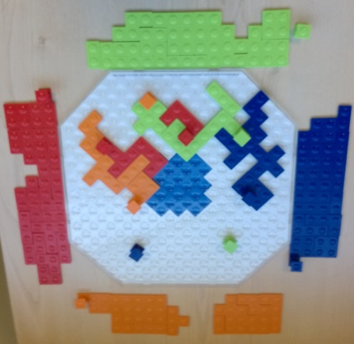

Want to look further? Look at tiling or bin packing.

