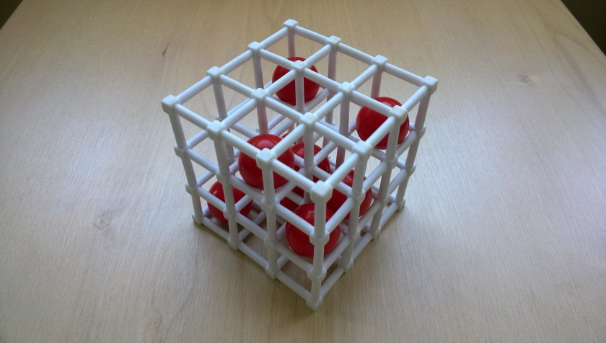
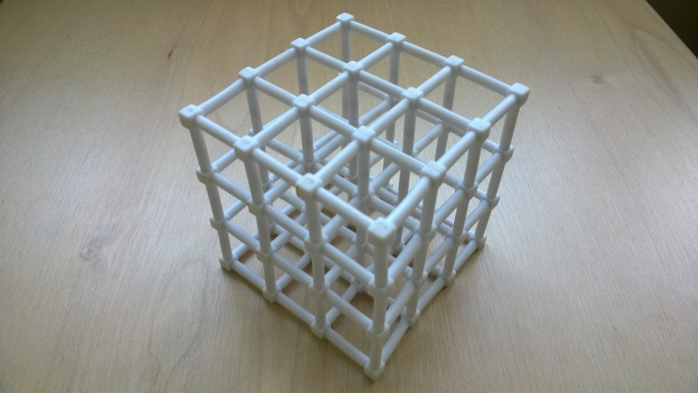
Cubulus – How to Play
Estimated play time:
20 minutes
Players: 2-3

Cubulus is a 2- or 3-player game where the aim is to create a square of four spheres in your colour on any face of the sphere. They are created in the following three ways.

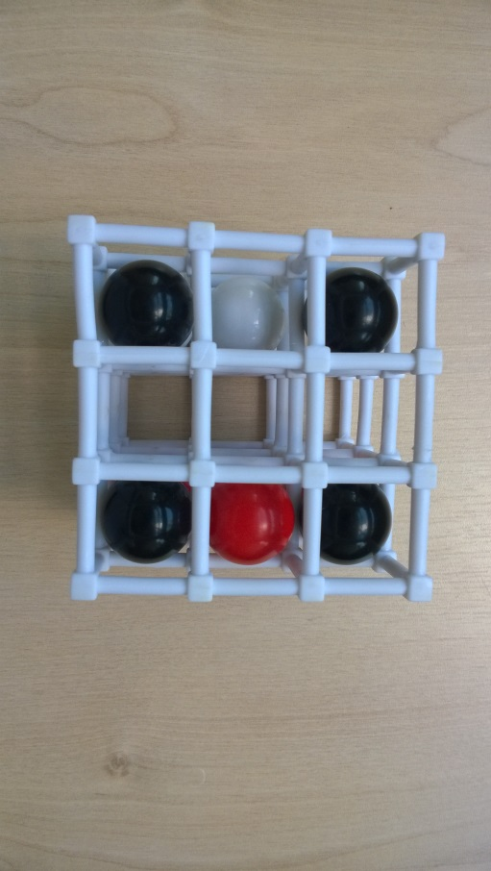
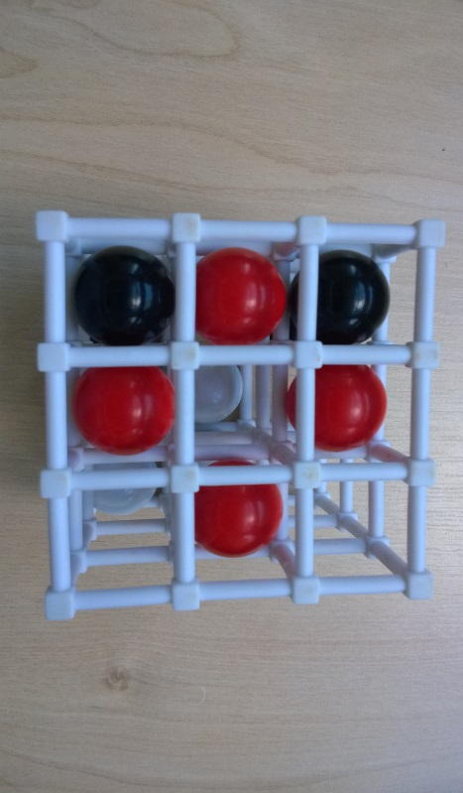
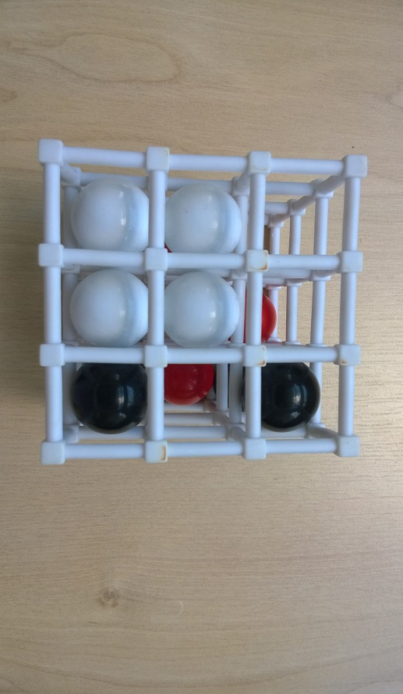

The 2-player version of this game starts with the person who isn’t having the first turn freely entering the 9 neutral spheres into the cube. After that, each player takes turns to push their spheres into the cube trying to make a square on any face. The 3-player version starts with an empty cube as no neutral colour is available.

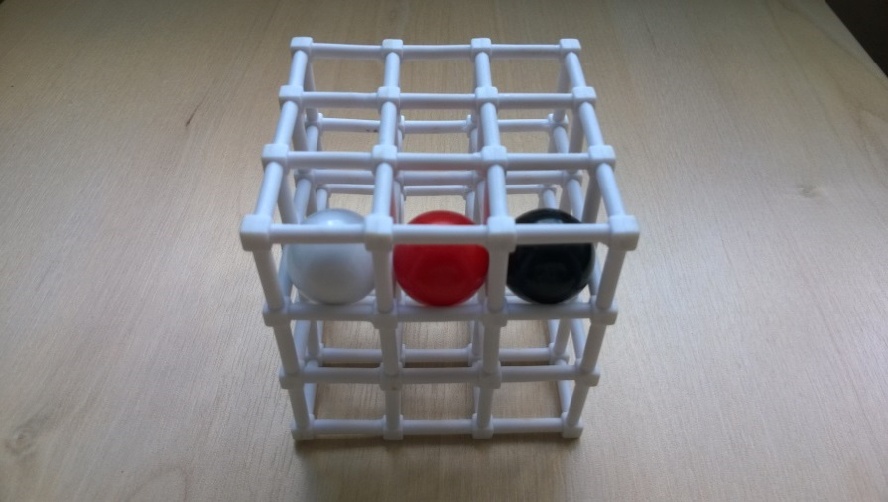
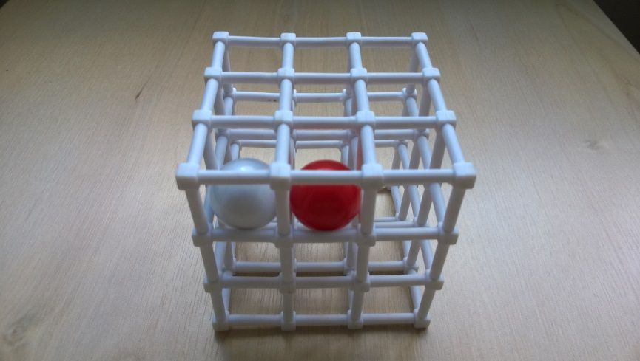
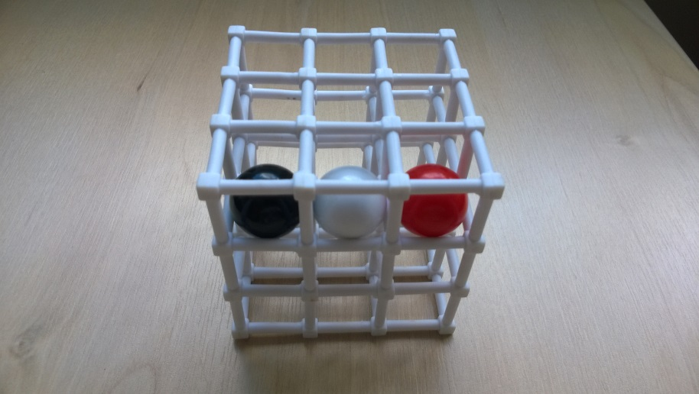
Spheres can only be entered into outside slots and can only move 1 or 2 other spheres in the cube. Instead of placing a new sphere, a player can push a row that is full through so a sphere comes out from one end, then they place it back into the newly emptied slot at the other end. However the next player cannot do the reverse on their move.
Cubulus – Strategy
Is there an advantage to playing in the corners of the cube or along the edges or middles?

Do you want to play on the same sides as your opponent or keep away from those sides?

Would it be more beneficial to group your colours to focus on one face on the cube? Or spread them to cover many faces?

What is the best move to make in this scenario, if you are white? (Try to make this configuration to play with this scenario.)

Top Level

Middle Level

Bottom Level

