Hex – How to Play
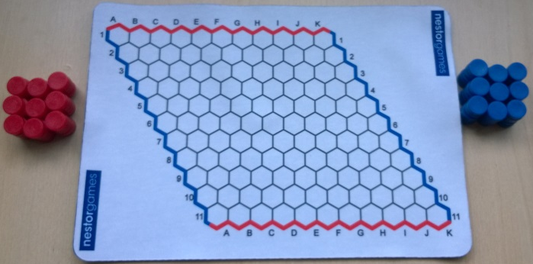
Estimated play time:
20 minutes
Players: 2

Hex is a 2-player game where the aim is to create a connected line that joins two opposing sides, vertically or horizontally, faster than your opponent who will try to connect the other two sides.

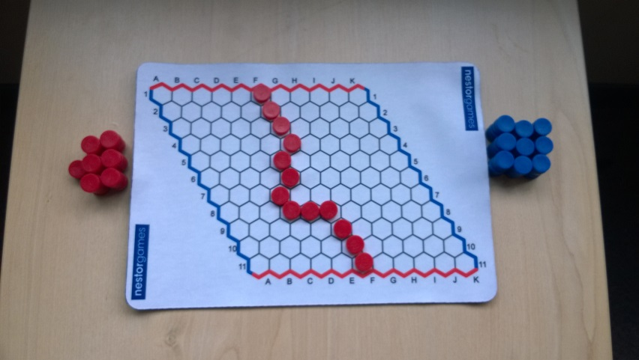
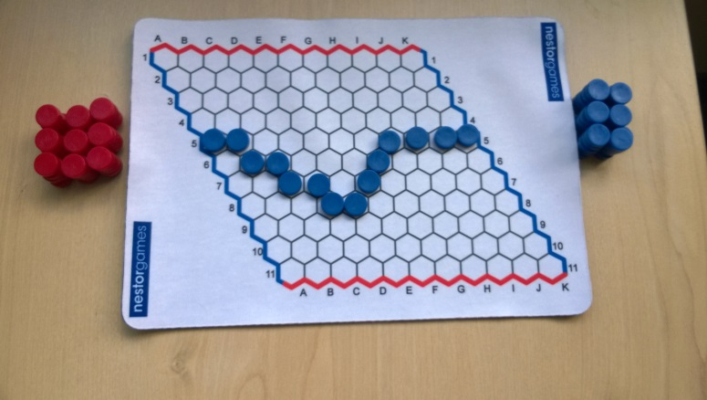
Each player starts with their own colour and takes turns to place a counter on the board trying to connect the sides that correspond to their colour. Therefore, one player is going horizontally and one is going vertically, the only way to completely block off your opponent is to create a winning connected line.

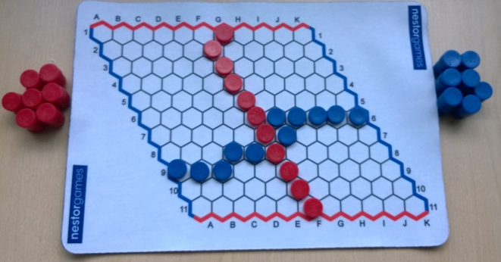

There is a rule at the start of the game where, if the player who goes second wishes, they can replace the first counter that was played with one of their own instead of making a move. However, this can only be done for the first counter.

Hex – Strategy
When placing your pieces in the early stages do you want to start in the middle or near one of your sides of the board?

Is there a way that you can have two counters that are not touching on any side but still cannot be blocked from being connected?

When your opponent starts the game, where on the board would you not find it an advantage to use the counter change rule on the first round?

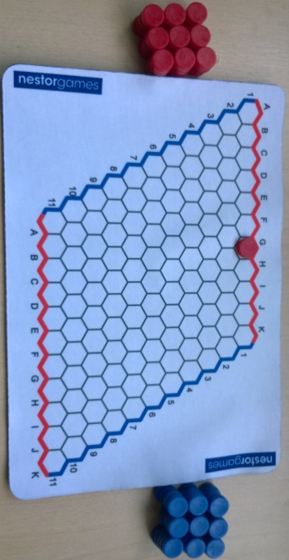
What is the best move for blue to make in this scenario?

Want to look further?
There are many variations of Hex; also look at the work of John Nash.

