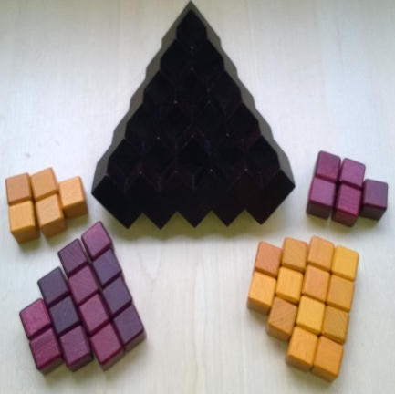
Inside – How to Play
Estimated play time: 10 minutes
Players: 2

Inside is a 2-player game where the aim is to have more cubes of your colour showing on at least 2 of the sides. The person who has more of their colour on a side wins that side, then whoever wins the most sides wins.

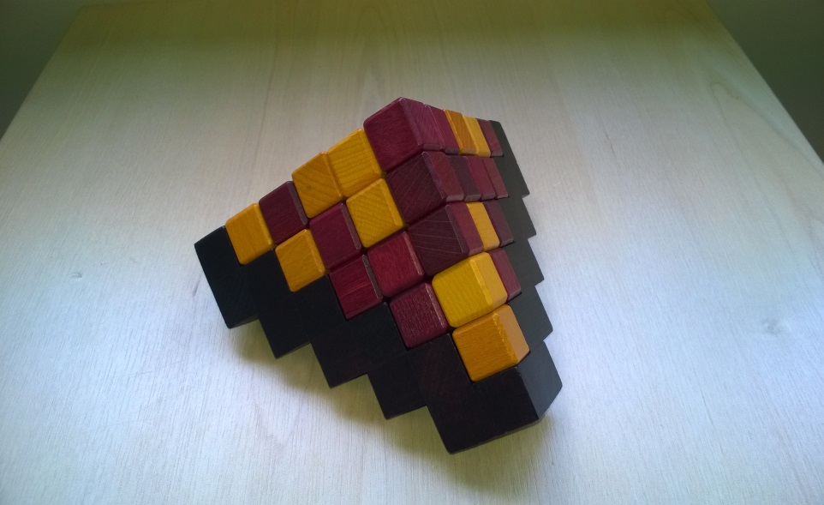
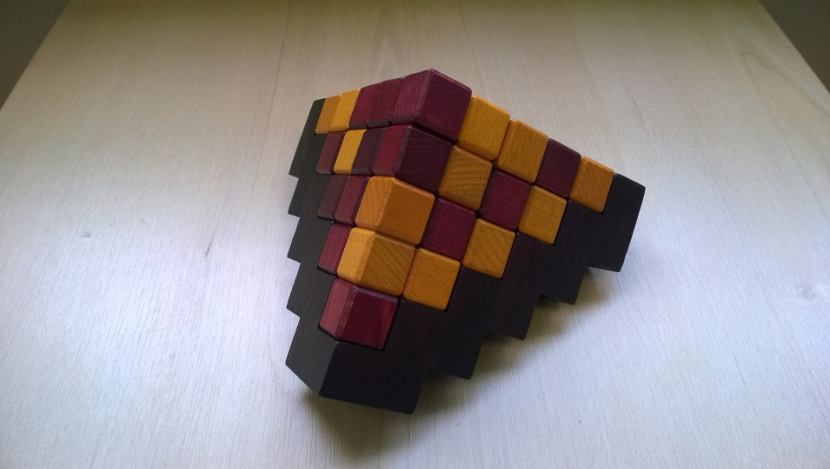

Each player starts with 13 cubes of their own colour and 5 cubes of their opponent’s colour. On each turn, players place one of their cubes of either colour on the board, until the pyramid is complete.

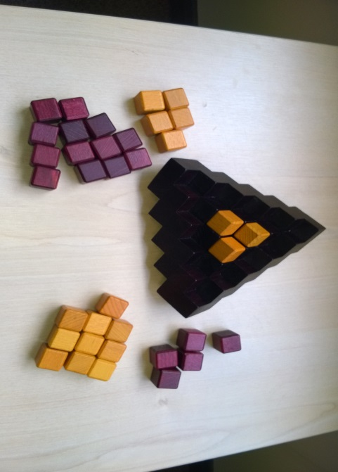
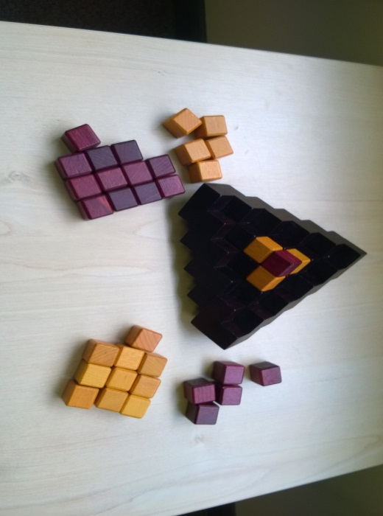
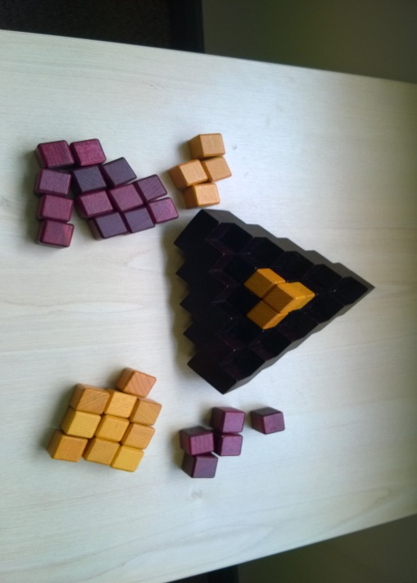
3
2
1
If a player places a cube such that it creates a new space to place a cube surrounded by the same colour (as in picture 1), they must take any cube from their opponent and fill in the created space (as seen in pictures 2 and 3).
If one player runs out of cubes the other can finish the pyramid with theirs.

Inside – Strategy
Do you need to win every side of the pyramid?

Is there an advantage to placing your cubes on the edges and top of the pyramid?

Is it better to get rid of the cubes your have in your opponents colour first?

Is there a way to win all three sides? How?

What is the best move to make in this scenario, for the player on the right?
(3 angles on the same pyramid are shown – try to build it to investigate this question.)

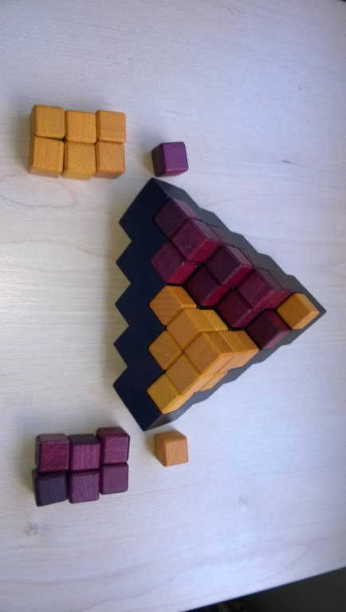
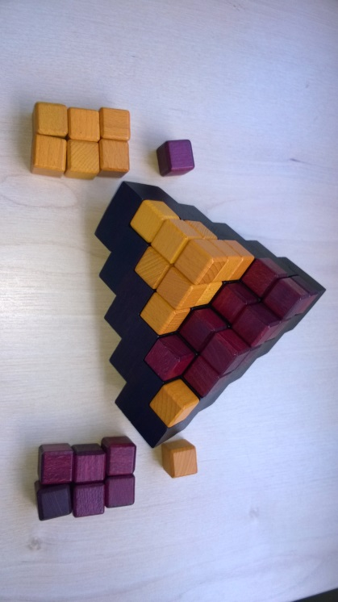
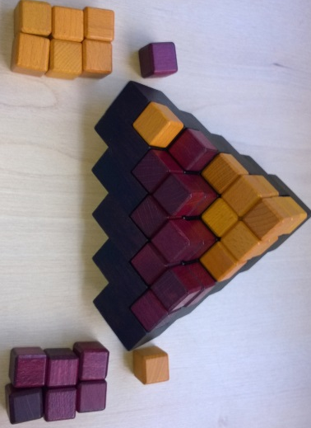

Want to look further? Look at tiling.

