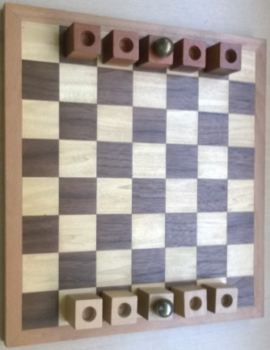
Knight Moves – How to Play
Estimated play time: 10 minutes
Players: 2

Knight Moves is a 2-player game where the aim is to get your sphere to the opposite side of the board, by moving it between your blocks.
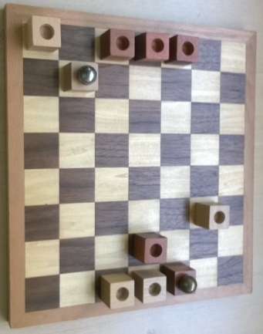

Each player takes turns to either move one of their pieces that have no sphere on top, or to move the sphere between the pieces in a path of straight lines in any direction. However, the path cannot pass any of your opponent’s blocks. If the path is unblocked you can move the sphere between as many of your own pieces in one turn as you want.

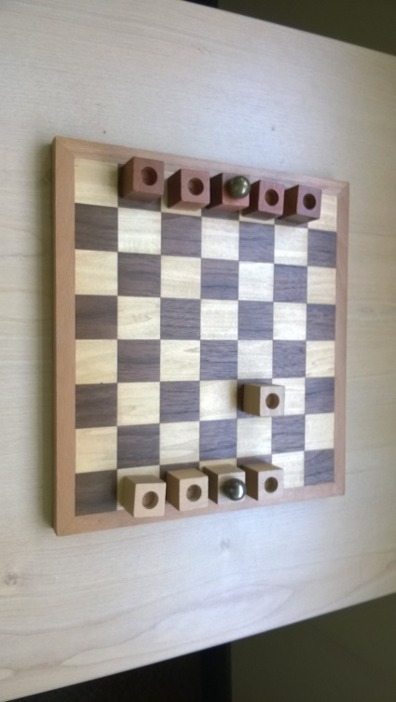
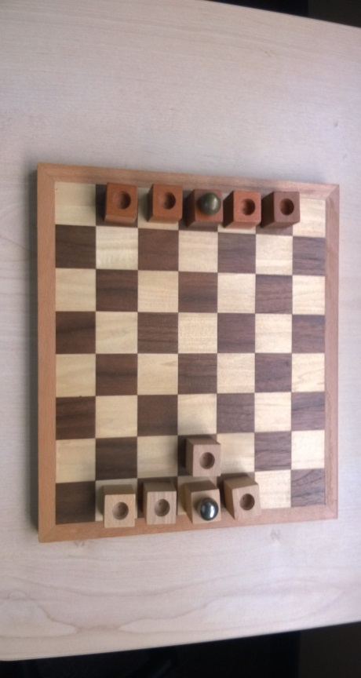

Pieces in this game, as the name suggests move like knights in chess, 2 squares vertically or horizontally then 1 square over to the side. Pieces can jump others. However, the pieces with a sphere on them cannot move while the sphere is still on top of them.

Knight Moves – Strategy
Should you leave some pieces near to your own side of the board?

Is it better to keep moving the sphere or just try to create one long path to win in one sphere movement?

Is it be easier to win if you keep your pieces close together or seperated across the board?

What is the best move to make in this scenario, for white?

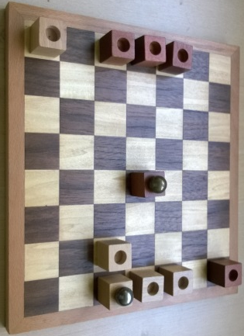

Want to look further? Look at the Knights’ tour problem.

