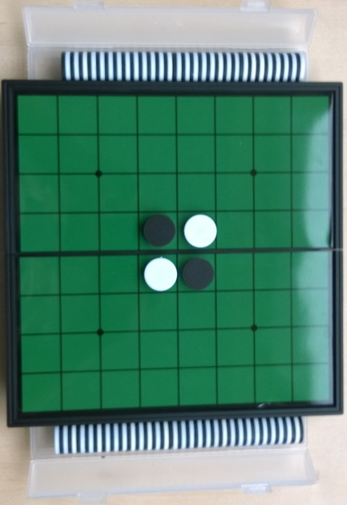
Estimated play time:
30 minutes
Players: 2

Oshello (Othello, Reversi) – How to Play

Oshello is a 2-player game where the aim is to have the most counters with your colour facing upwards at the end of the game. In order to turn more counters to your colour, you place one of your colours at both ends of a line of your opponent’s counters. This flips all enclosed counters to your colour. The position above is turned into the one below by the placement of one counter by white.

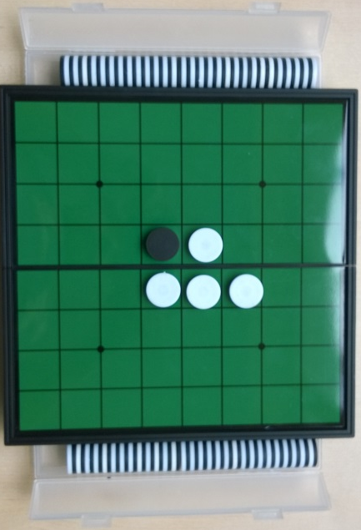

Each player takes turns to play a counter with their colour face up. They must play next to an already placed counter and in a way that causes at least one of their opponent’s counters to flip.

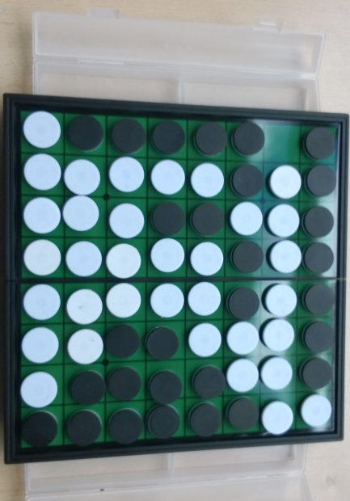

If a player has nowhere that they can play then they must pass on their turn. The game ends when either the board is full or neither player has a place that they can play. Then each colour is counted and the player with the highest number of counters in their colour wins.

Oshello (Othello, Reversi) – Strategy
Is there an advantage to having your counters covering the edges on the board?

Are there any spaces you need to keep your opponent away from?

Is there a way that you can prevent your opponent from easily taking back the counters you just took?

What is the best move for black to make in this scenario?

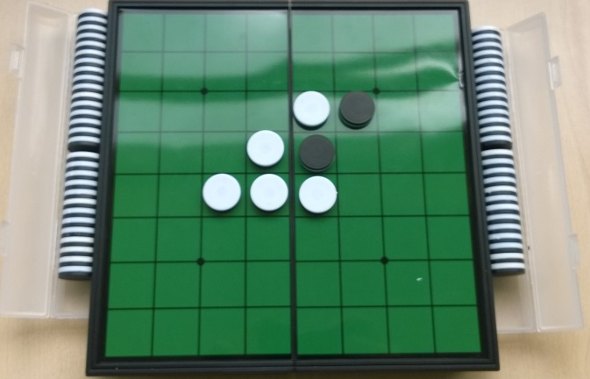

Want to look further?
Look at tile placement. Also look at Go as both games use area enclosure.

