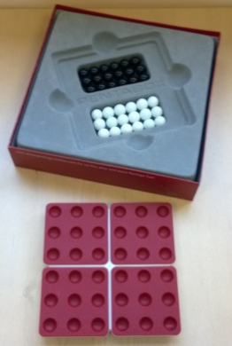
Pentago – How to Play
Estimated play time: 5 minutes
Players: 2

Pentago is a 2-player game with the aim of creating a line of 5 marbles in your colour in a row. This can be in a horizontal, vertical or diagonal direction across the board as in images 1, 2 and 3.

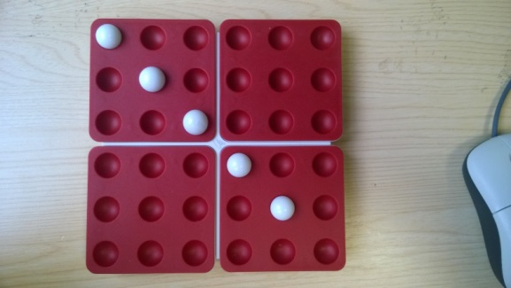
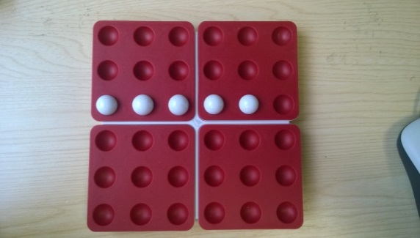
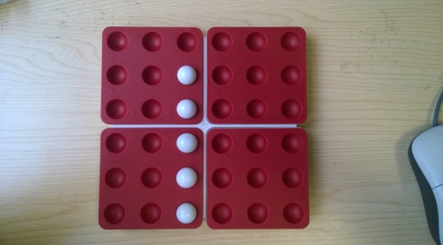
1
2
3
In order to do this each player takes turns to place a marble on the board and then rotates one of the 4 sections 90º (1 notch) in either direction to finish their turn. The rotated section doesn’t have to be the one that the marble was placed on.

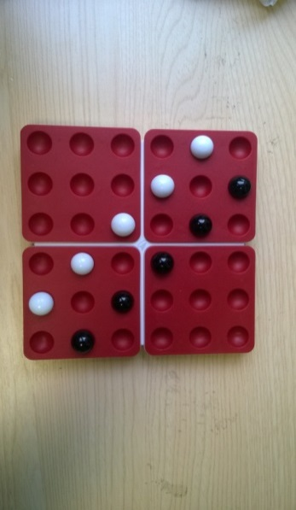
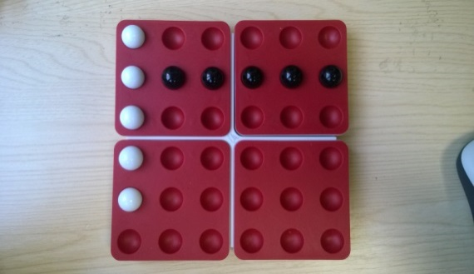
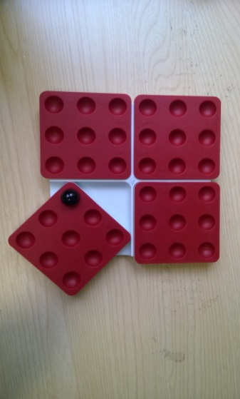
The win can happen before or after the rotation, however if a player rotates the board and creates 5 in a row in both colours the game is a draw. If all the marbles are placed then at that point the game finishes in a draw.
Pentago – Strategy
Does it help to have the middle of the board controlled by your colour?
Is there an advantage to controlling the middle of a rotating quadrant?

How can you use 3 rotating sections to make one 5 in a row?

What should you be aware of if your opponent gets to here?

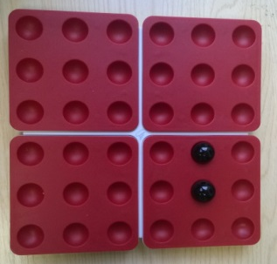
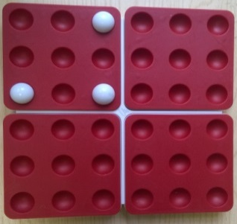
Would creating this scenario on one of the quadrants be useful?

