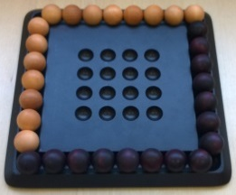
Pylos – How to Play
Estimated play time: 10 minutes
Players: 2
Pylos is a 2-player game where the aim is to build a pyramid with the sphere on the 4x4 grid and the person who places the sphere at the peak wins.

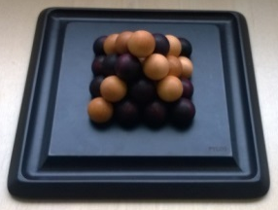

To do this each player takes turns to place a sphere of their colour onto the board. Once a square of spheres has been formed, the next player has 3 options; they can take a sphere from their reserve and put it on top of the square, move a sphere up from a lower level therefore saving your reserves or take a sphere from their reserve and place it elsewhere on the board as normal.

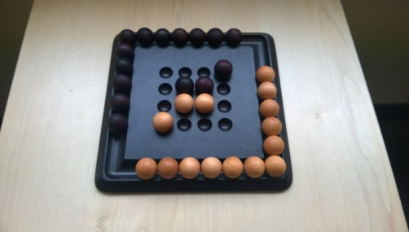
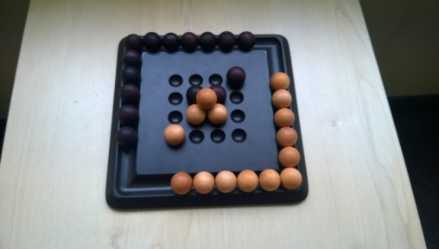
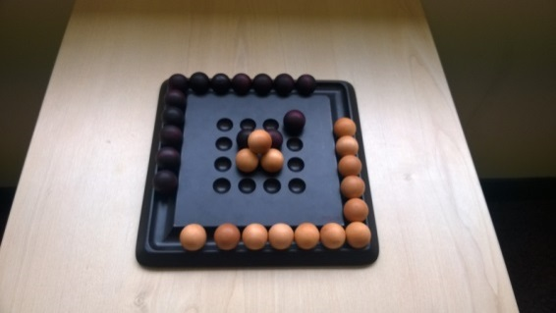
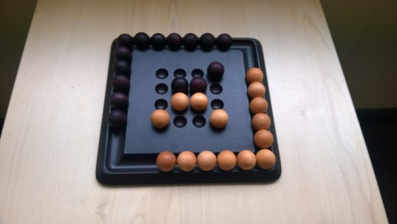

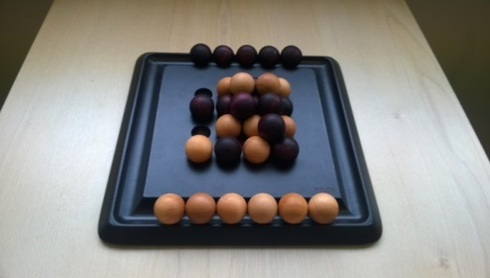
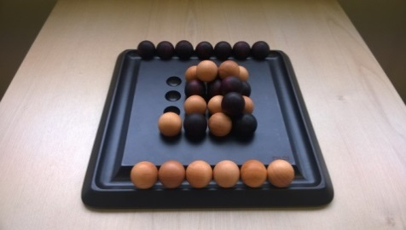
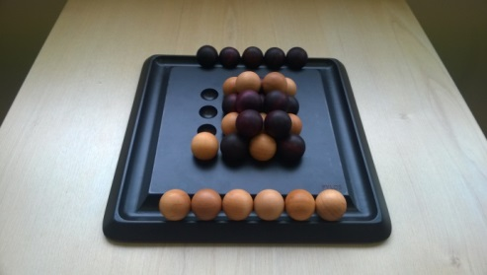
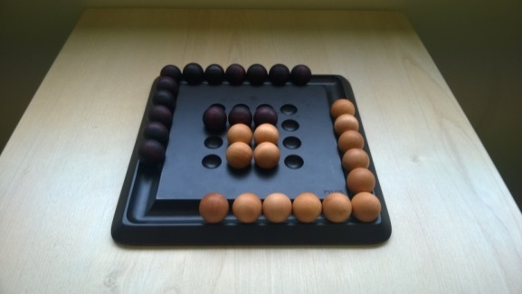
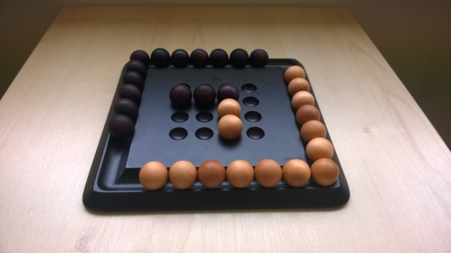

For the basic version of the game, if you create a square of your own colour as in the image below, you must remove either 1 or 2 of your spheres from anywhere on the board and return them to your reserve, provided that you don’t remove any spheres that are supporting any other spheres.

It is also possible in one turn to lift a sphere from one level to make a square then having to take back one or two spheres.
Pylos – Strategy
Is there an advantage to starting off in the corners of the board?

How can you ensure that you create a square while on the ground level?

When is it more advantagous to build a mixed square?

What is the best move for white to make in this scenario?
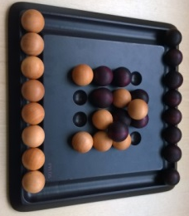

Advanced game
There is a more advanced version of Pylos where if you create horizontal or vertical lines of your colour across the board, it has the same rules as when a square of the same colour is created. Hence if a row of 4 on the base or row of 3 on the first level is created you must take 1 or 2 of your spheres back to the reserve.

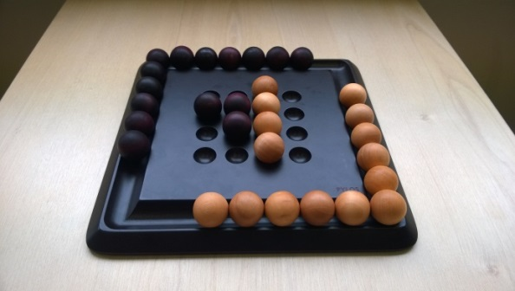
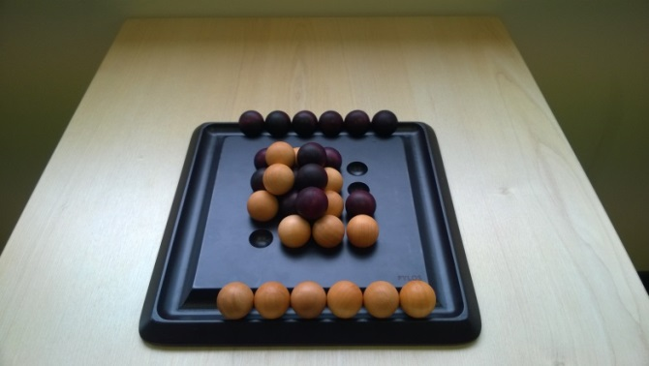

Want to look further? Look at sphere packing.

