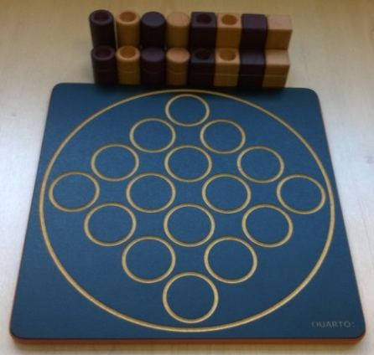
Quarto – How to Play
Estimated play time: 10 minutes
Players: 2

Quarto is a 2-player game where the aim is to create a line in any direction of 4 pieces which match in one or more of the following characteristics: round or square; light or dark; short or tall; solid or hollow.

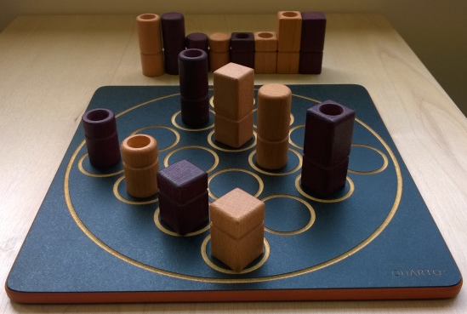

For each move one player passes their opponent a piece to place on the board. Therefore the aim is to get your opponent to pass you a piece you can win with.

.

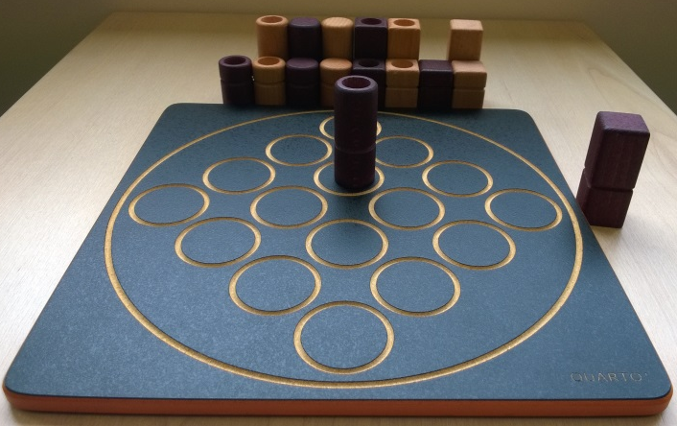

Once a winning line has been created the player must call ‘Quarto’. If they don’t notice and hand a piece to their opponent, the second player can call ‘Quarto’ and win the game immediately. If neither player calls ‘Quarto’ within the round that the line has been created the game continues and the line becomes uncallable. If no ‘Quarto’ is called the game ends when all the pieces are on the board.

Quarto – Strategy
Is there an advantage with starting off in the corners of the board?

Is it better to attempt to limit the options as much as possible or to maximise them?

Do you want to give your opponent a piece that closely resembles the piece you have just played, or is as far away as possible from a match?

What is the best move to make in this scenario?

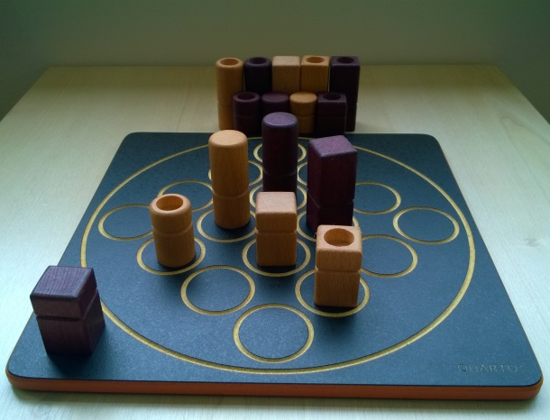

Advanced Game
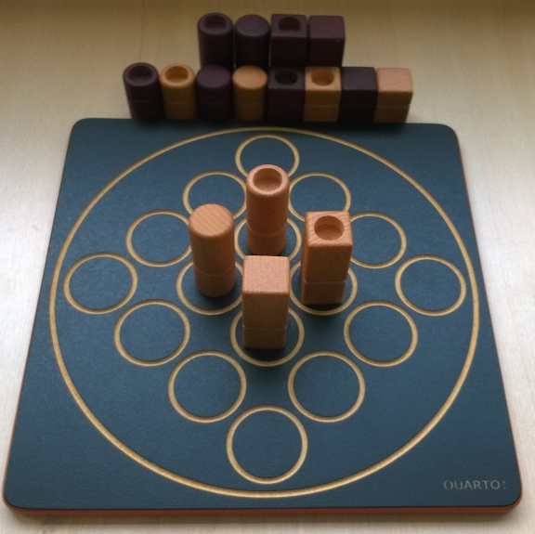
Want to look further? Look at using binary numbers in this game.

In quarto there is an advanced game in which Quarto can be called for squares of the same characteristic as well as lines. This therefore allows 9 more ways in which you can win a game, and also loose a game. Below is a winning square of white pieces.

