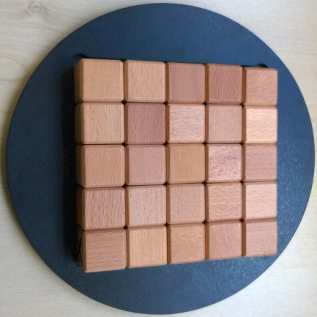
Quixo – How to Play
Estimated play time: 15 minutes
Players: 2

Quixo is a 2-player game where the aim is to get 5 in a row, in your chosen symbol. The line can be in any vertical, horizontal or diagonal line.

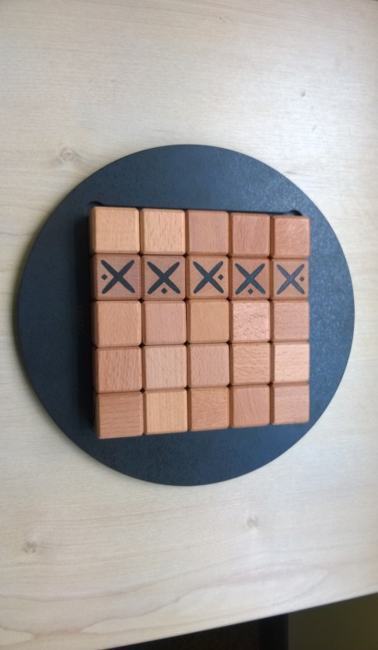
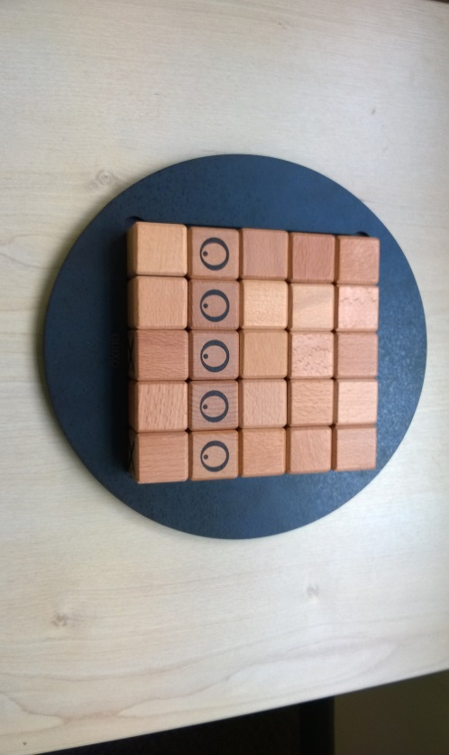
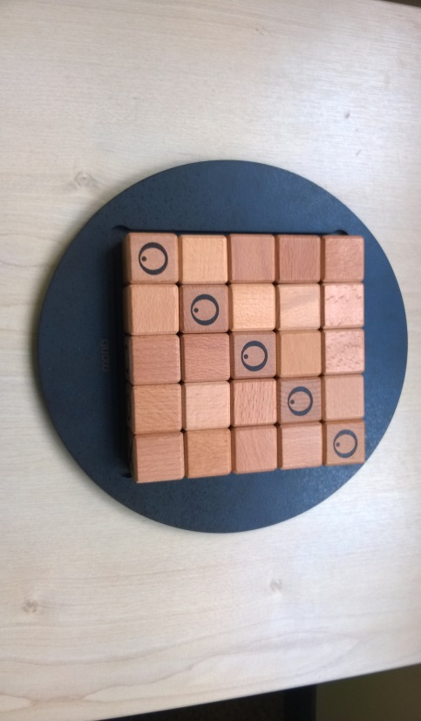
The game starts with all the blocks showing the blank side. Each player takes turns to choose any block from the edges of the board, pull it out from the board and turn it to their own sign. This block can be blank or of that player’s symbol. Following this they must then push it back onto the board at one of the other sides in the same row or column so it causes the board to be full again.

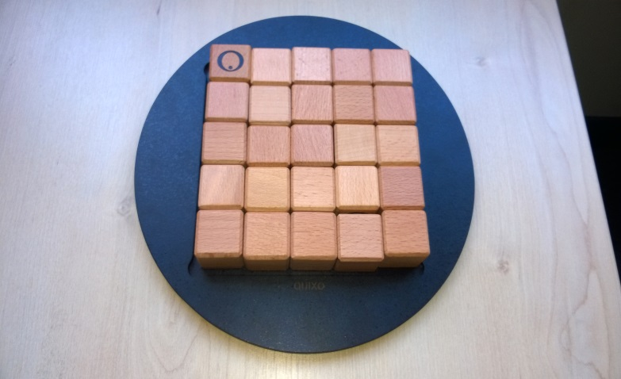
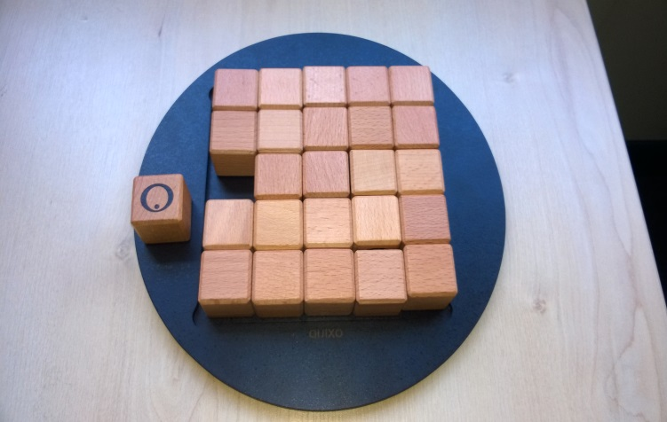

Players cannot take a block that has their opponents sign on it and they cannot replace the block in the same spot that it came from. If a person makes 5 in a row of their opponents sign they lose even if this makes 5 in a row of their own at the same time.

Quixo – Strategy
Is there an advantage to continuously placing your blocks in the same place?

Is it advisable to focus on the middle row and column, or the edges?

Is it better to stay away from your opponent for as long as possible or play as close as possible?

What is the best move for noughts to make in this scenario?

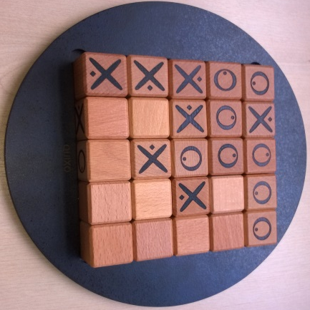

Want to look further? Look at work on Noughts and Crosses (or Tic-Tac-Toe).

