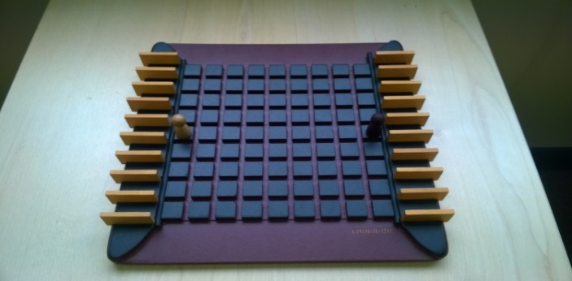
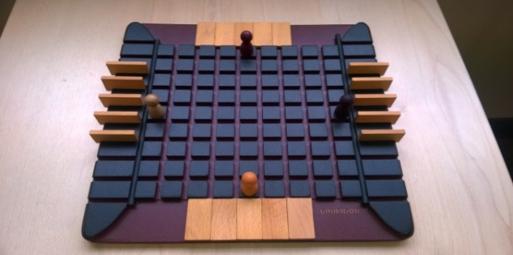
Quoridor – How to Play

Estimated play time: 15 minutes
Players: 2 - 4

Quoridor is a 2- or 4 player game which the aim is to get your figure to the side of the board which is opposite to where it started.
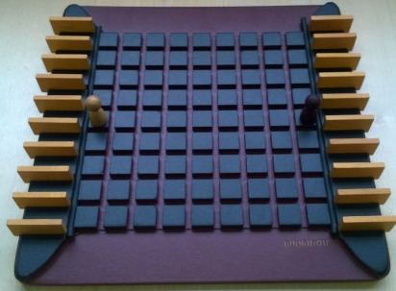

In a 2-player game each player starts with 10 fences and their pawn in the middle of the first row of your side of the board. In the 4-player version each player has 5 fences instead of ten. On each turn the player decides to move their pawn horizontally or vertically one space, or place a fence anywhere on the board. Fences cannot be passed over; also, they cannot completely prevent any player from reaching the side of the boards they would win at.

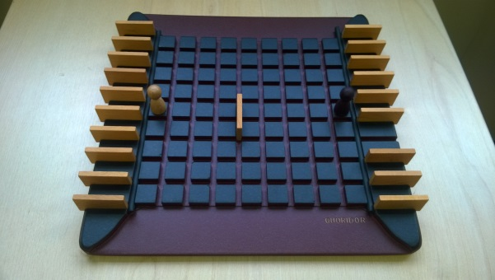
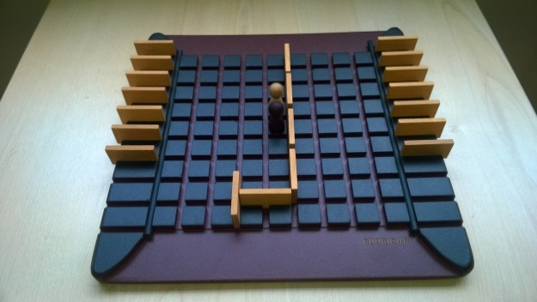

When placing a fence it can only run alongside, hence block off, 2 squares as shown in the left hand image above. When 2 pawns are adjacent to eachother (image 1), the player whose turn it is can choose to jump over the other pawn. If there is a wall on the other side of the pawn, image 2, the jumping player just moves to either side of the jumpped pawn, image 3. In the 4-player game you cannot jump more then one pawn.

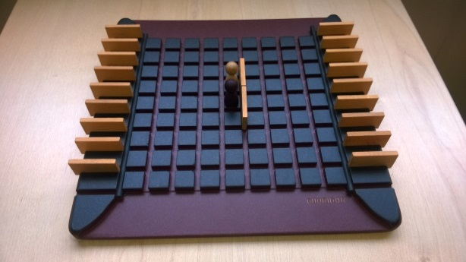
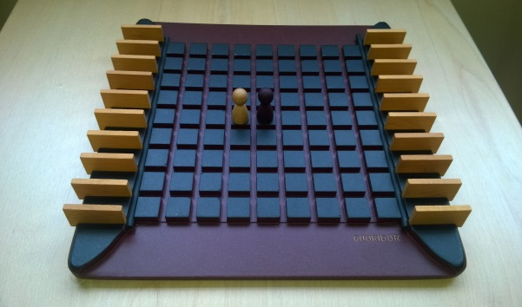
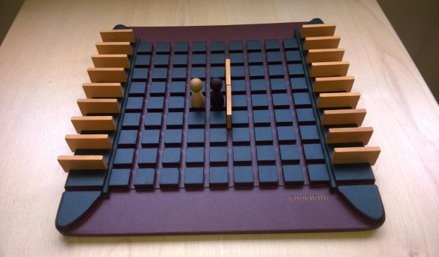
3
2
1

Quoridor – Strategy
Is there an advantage to saving your fences to later in the game?

Do you have to use your fences to block your opponent, or is there another use for them?

In a 4-player game would you want to try and work with and particular players?

Here, black is moving right to left and white is moving left to right.
What is the best move for black to make in this scenario?

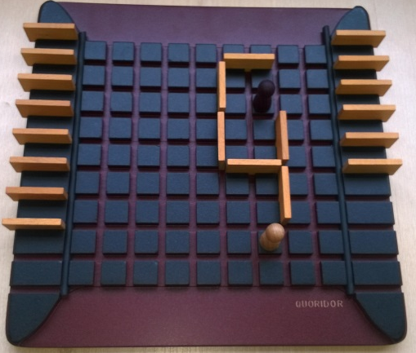

Want to look further?
This game is perhaps related to Conway’s theory about playing two games at once.

