
Solomon’s Stones – How to Play
Estimated play time: 5 minutes
Players: 2

Solomon’s Stones is a 2-player game where the aim is to force your opponent to take the last stone, as the person who takes the last stone in the loser.


On each turn a player can take 1 or more stones from a row or column, not a diagonal. The stones taken do not have to be adjacent to each other, for example a player can take every other stone in that row if they wanted.

.
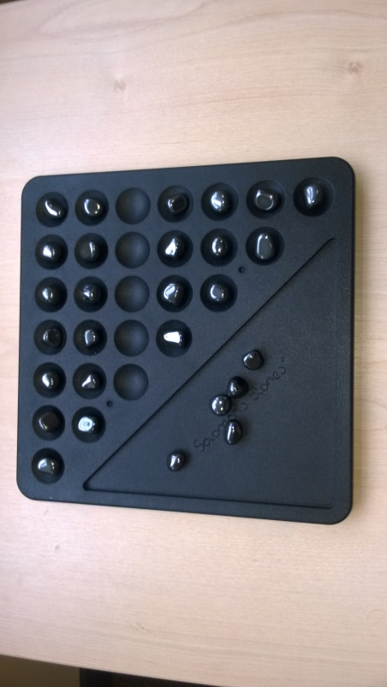


Players must not take stones from more than one line on any turn or take from diagonal lines.




Solomon’s Stones – Strategy
Would it be to your advantage to leave your opponent with 3 stones that are diagonal to eachother?

Is it better to remove lots of stones quickly early on in the game?

What is the best move to make in this scenario?

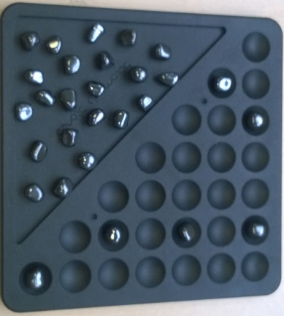

Want to look further? This game is similar to a game called Nim.

