Stratum – How to Play
Estimated play time: 20 minutes
Players: 2 - 4

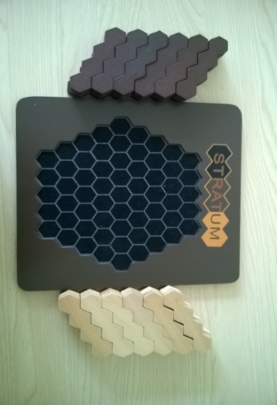
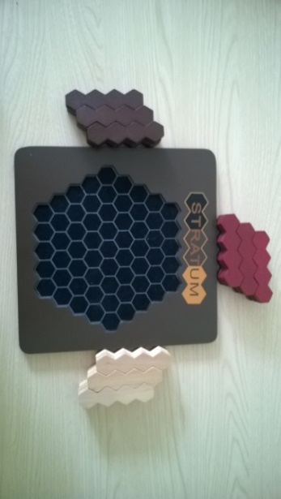
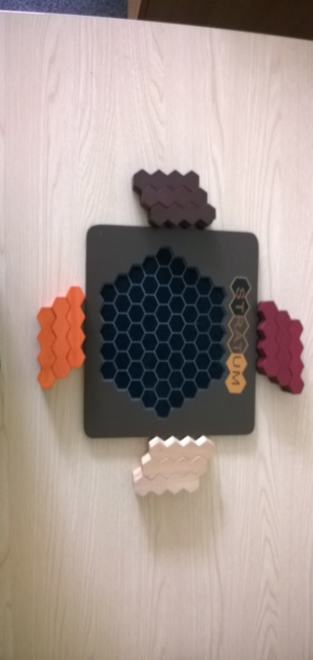

Stratum is a 2-, 3- or 4-player game where the aim is to have the largest amount of your colour visible from a birds eye view.

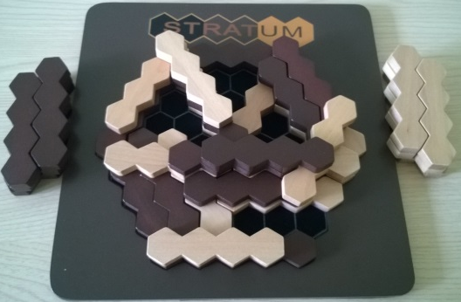

For the 2-player version each player has 18 of their respective colours. 3-player games each player starts with 12 and 4-player games have 9 pieces each. Each player takes turns to place one of their pieces on the board, lining up with the grid in any direction. Only when there isn’t space to play on the bottom level are pieces played on top of the already placed pieces.

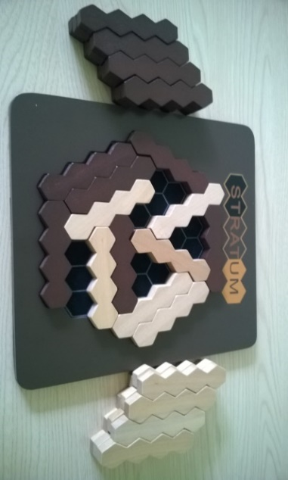
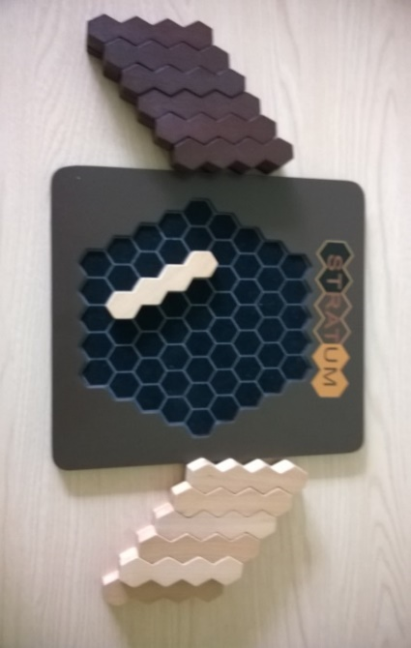

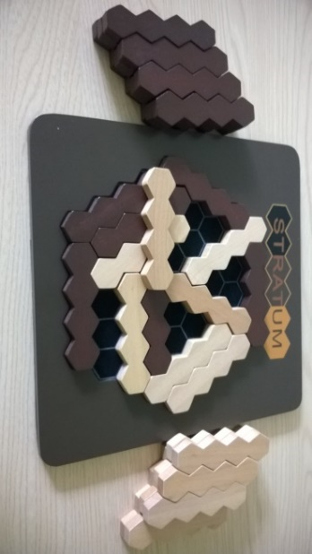
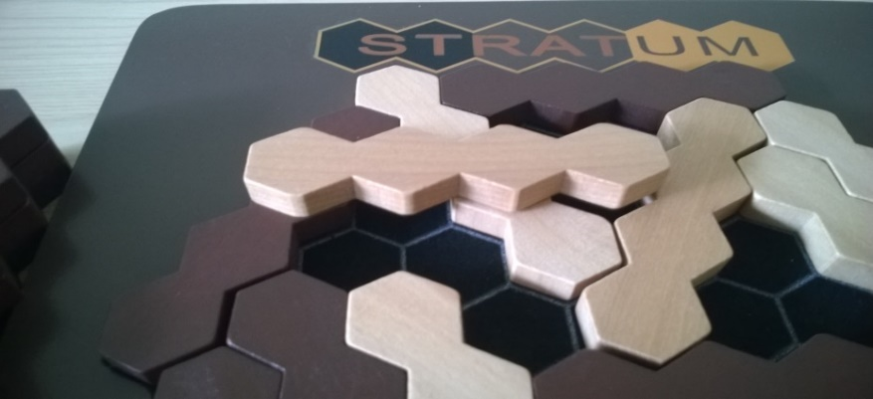
When it comes to placing on the upper levels each new piece must cover more than 1 different lower level pieces, as in image 1. No piece may have a gap under it (like a bridge), like image 2 shows. As each level is filled then the play is taken to the next level up.
1
2
Stratum – Strategy
Do you want to maximise or minimise the amount of space that is playable on the upper levels?

Can you find a way to block areas of your colour from being able to be played on?

Would it be advantagous to space out your pieces?
What is the best move for brown to make in this scenario?

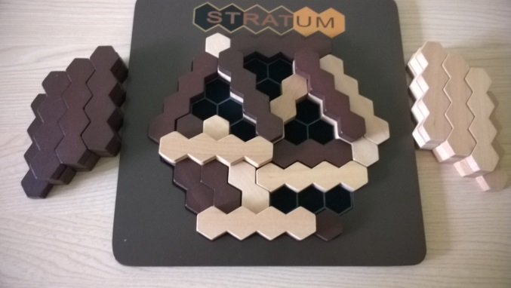

Want to look further? Look at Tiling. Also look at Go as both games use area enclosure

