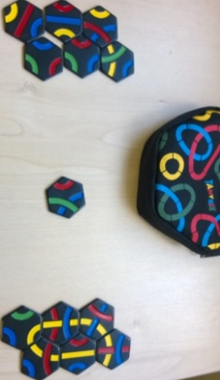
Tantrix – How to Play
Estimated play time: 30 minutes
Players: 2 - 4
Tantrix is a 2-, 3- or 4-player game where the aim is to get the longest connected line or loop in your colour. Each tile the line covers earns one point. A loop is a line that connects back on itself and counts for twice the number of tiles it covers.

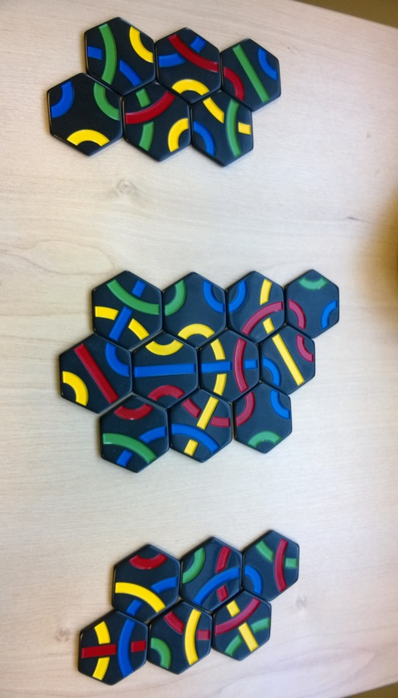
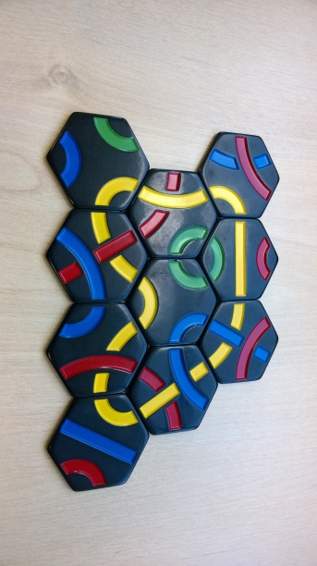

To choose who starts, each player picks a tile from inside the bag and whoever has the highest number on the back starts the game. After this each player takes 5 more tiles to make up their 6 tile hand that they leave visible. Each player then takes turns to place a tile and pick up a replacement from the bag. Each placed tile must match its colours to the adjacent one.

When three tiles are in a row as the image below shows, this creates a forced move which must be filled in on your turn, if possible. When you have filled all the forced moves you can, then you get your free move which you can play anywhere. Following your free move you must fill any forced moves again. Once you have gone through these three steps while replacing any used tiles the turn is passed to the next player.

.
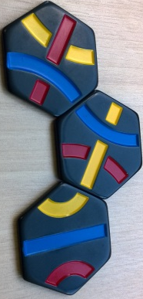
There are three restrictions to where you cannot play your tiles. Firstly, you cannot create a forced move where all three surrounding tiles have the same colour connecting to the space, see image 1. Secondly you may not surround a forced move space with 4 or more tiles, as image 2 shows. And thirdly you cannot play along sides where a forced move is, as in image 3, as this will eventually create the restricted move in image 2. However, when the bag is emptied these restrictions no longer apply.

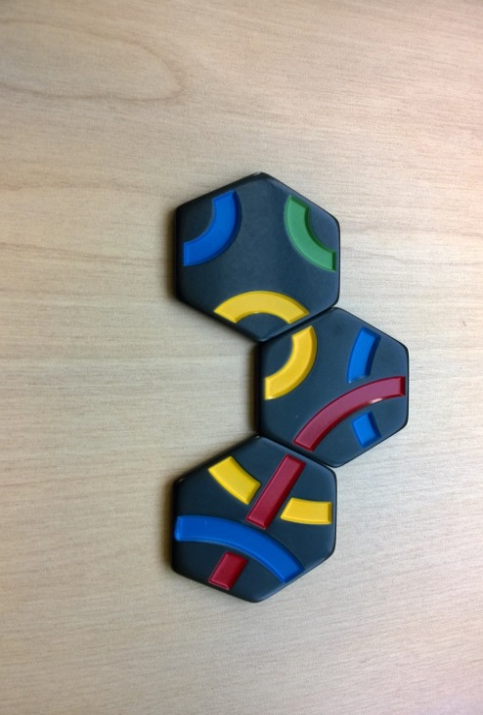
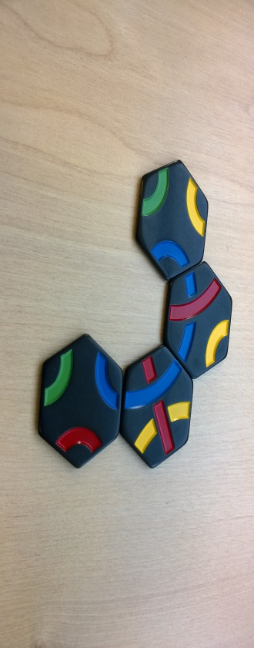
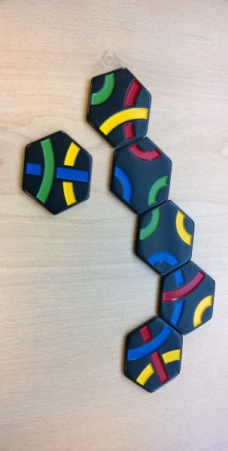
1
3
2

Tantrix – Strategy
How can you utilise forced moves to help increase your chance to win?

Is there a place where creating loops of your opponents colour is a good idea?

Once the bag is empty what could you do to prevent your opponents from progressing their lines?

What is the best move, for blue (right) to make when playing against yellow (left), in this scenario?

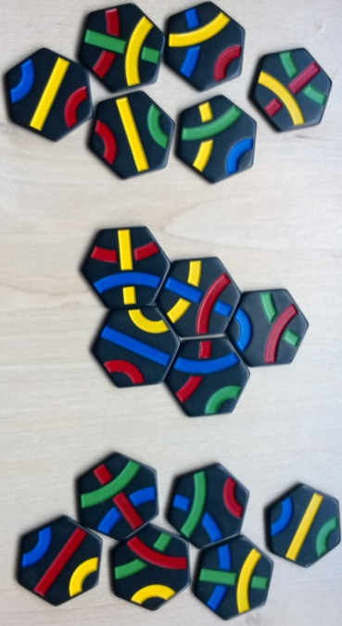

Want to look futher?
Look at tile placement. Also see, solving Tantrix via integer programming.

